
Supporting Documentation - EquiMap
Max

May 21, 2025

Table of Contents
Contents
Table of Contents 1
Introduction 3
This is the link to our app; you can install it on an Android phone: EquiMap-Final-Build 4
System Overview. Based on C4 architecture (Brown, 2025) 4
Mobile App 4
Core functionality summary 4
Technologies used 5
Database 6
High-Level Architecture Description 6
A simplified C4 Component view 7
Core Functionality Summary 7
Scraper 7
C4 Architecture 9
Tests 10
High-Level Architecture Description 10
Core Functionality Summary 10
Technologies Used 11
Technical Documentation 11
Mobile App 11
System Requirements 11
Database design 12
Overview 12
Data model and table structure 13
Data types and limitation 13
Security Considerations 13
Database 13
Maps 14
Testing & quality assurance 14
Testing methodology (unit, integration, user testing) 14
Summary of bugs, fixes, and performance improvements 15
Login and Sign-up 15
Map 16
Featured menu 18
Place 18
Settings 20
Filter page 21
Menu 22
Results from user feedback 22
User Documentation 23
User interface overview 23
How to use features 24
Tips on the Use of EquiMap 24
Brief product history 25
Mobile app’s development history 26
Project management & collaboration 27
Tools used 28
Roles of team members 29
Project Review & Reflection - Max 29
Engagement and Contribution 32
Attendance at Innovation Lab sessions 32
Additional input 32
Weekly meetings 32
Managing team members 32
Other Small Contributions 32
Reflection 33
References 33
Appendices 35
C4 architecture diagram 35
Appendix A: 35
Appendix B: 37
Appendix C: 38
Appendix D: Table displaying Place database 40
Appendix E: Example of how information is being stored in the database 41
Appendix F: Database design 42
Appendix G: SQL code 42
Appendix H: Research design settings 44
Fonts 44
Color palettes 45
Icons 47
References 48
Appendix I: Filter Screen 48
Appendix J: Place place 60
Appendix K: Settings page 74
Appendix L: Map 80
Appendix 86
Appendix N: 88
Appendix O 100
Appendix P 103
Appendix Q 105
Appendix R 106

Introduction
EquiMap is a professional map and guide app offering detailed insights into accessibility features across select locations in Bath. Perfect for users prioritising accessibility with various additional needs, it empowers people to plan in a simpler and more effective way. The broad scope of existing map-based applications means that they often lack targeted information. This is a gap we intended to bridge with EquiMap. Not only does our product provide a greater variety of accessible information to its userbase, the app itself is designed with our target audience in mind. We provide an experience tailored to each user with various in-app adjustments which cater to people with less motor functionality or impaired colour vision, whilst maintaining professional standards regarding visual hierarchy and page layout. In adhering to known principles, we are allowing more people to pick up our app and intuitively know how to use it.
This is the link to our app; you can install it on an Android phone: EquiMap-Final-Build
https://bathspaonline-my.sharepoint.com/:f:/g/personal/kate_maistrenko22_bathspa_ac_uk/ElMBDl_lrQpDo8LF4emMk5YBHiGdjLKEBIC0VS1O_SWH8Q?e=pe8VzN

System Overview. Based on C4 architecture (Brown, 2025)

Mobile App

Core functionality summary
The mobile app is how the users interact with our service, which is why it was the first part of the project to be designed. All the screens have undergone multiple iterations, and have had their appearance altered, but the core functionality has remained mostly unchanged from our original design.
When the user opens the app, they are shown the map of Bath and its surrounding area. The map shows the user the many different places of interest in the city by using interactive markers (pins) on the map. The user’s location is also marked on the map to allow them to easily navigate around the city and/or their surrounding area. Near the bottom of the screen the user is also shown a menu they can open to view a set of recommended locations the app chooses based on their preference data.
At the top of every screen of the app, a header bar is displayed. It displays the name of the currently viewed screen, or the name of a location. This header bar also allows the user to navigate to the app’s settings screen or navigate back to the previous screen. While the user is on the main map screen, the app also gives them an option to navigate to the filter screen. The filter screen displays a list of locations to the user. It also gives the user an option to specify from a list of filters, which ones they would like applied. The app then uses these to filter out unwanted locations from the list of locations shown on the filter screen.
Several of the filters available to the user on the filter screen are unique to the filter screen, allowing the user to manipulate the list of places based on what they need at any given moment. However, other filters, related to the user’s accessibility needs, can also be toggled within the app’s settings. This was done so that the user does not have to change the filters based on their specific accessibility needs every time they use the app. Instead, certain information could be tailored to an individual once, and other more dynamic information could be used to filter more precisely. The settings screen also allows the user to change and toggle accessibility features provided by the app itself, such as the colour palette.
Whenever the user selects a location on any of the screens, a new screen will appear, displaying information about the selected location. This screen provides the user with basic information about each location, such as its name, address, description, contact information, opening hours, as well as average ratings for the given location. This screen also provides the user with information about each location’s accessibility features and available payment methods through a set of selectable dropdown menus the user can open whenever they need them. The menus are hidden by default, and only one can be displayed at a time as to not overwhelm the user with information, and to allow for easier navigation through the app.
The app offers the users a wide range of accessibility settings, such as changeable colour palettes which can make the app easier to use for people with colour-blindness or dyslexia easier, as they can adjust the app’s appearance to suit their needs. To further improve the usability of the app for people with these difficulties, all the app’s text has been designed to use a large and easy to read font, and the app’s user interface has been designed so that all the interactable elements are large, making the app easier to use for people with motor difficulties.
Early prototypes of the app also had the ability to sign in and store the user’s data and settings in our database. However, these features have been removed in the latest version due to time constraints.

Technologies used
We wanted the app to be available on a wide range of devices, which is why we decided to create the app in the JavaScript programming language. JavaScript is a popular language which is usually used for developing websites and web apps. However, a wide variety of tools and frameworks have been developed to make the creation of native and mobile apps possible within it.
We decided to use of the popular React Native framework, which is a mobile app development toolkit based on the React framework which is used for creating websites and web apps (React Native 2024; Meta Open Source 2025). React Native allows for creation of apps which can work on multiple platforms. Furthermore, developing using the React framework is similar to other languages which some of us have used in the past. In addition to using React Native, we have decided on using Expo, which supplements React Native with its own set of tools and features (Expo n.d.). This has made compiling our app for mobile devices easier and has made implementing features such as multiple screens (map screen, filter screen, place screen) significantly easier (Expo Documentation. 2024). Expo also comes with several sets of commonly used icons, which our app uses to represent commonly used concepts and buttons (icons.expo.fyi. n.d.).
For creating the interactive map, we decided on using. MapBox is a service which redistributes map data from the OpenStreetMaps API and supplements it with its own information, like how we filled our own database. Both MapBox and OpenStreetMaps are well known providers of map data, and the information they provide is highly accurate. Access to the data provided by the MapBox service is protected through a set of API tokens, which our app stores in its config files with the use of the dotenv JavaScript library, which prevents them from accidentally being published online (npm, n.d.).
The app displays the interactive map to the screen using the rnmapbox library, which is a popular React Native library for displaying maps. It automatically fetches map data from the MapBox service using the access tokens and displays the interactive map to the user. Our app also generates a list of interactive markers from the data in our database, which it then draws on the screen through the rnmapbox library.

Database
System | Technologies Used
Database | MySQL
Hosting | PythonAnywhere (remote DB + server)
Backend | Python, Flask, Flask-RESTful, MySQL Connector
Testing & Integration | Postman (Postman, 2025)
Data Transfer Format | JSON (for API interactions)
Security/CORS | Flask-CORS

High-Level Architecture Description
On the Container level, as a MySQL relational database, EquiMap’s database serves as the main storage system for all information related to places in Bath for our team (Oracle Corporation, 2025). It works in conjuncture with the backend API, which interacts to handle client requests, and is ultimately accessed via the EquiMap app frontend.
The backend server, hosted on PythonAnywhere, acts as the middle layer between the mobile frontend and the database backend (PythonAnywhere, 2025). It exposes RESTful endpoints (using Flask and Flask-RESTful) which allow clients to interact with the data - fetching, adding, editing, and deleting accessible place entries based on developer needs.
All place entries are stored in a structured format inside the Place table. Each row represents a location which contains accessibility-related details such as wheelchair access or additional practical features like child-friendliness or seating options, along with generic data such as place name or place address.

A simplified C4 Component view
Frontend (EquiMap App) → sends API requests
Backend API (Flask app on PythonAnywhere) → processes logic and talks to
MySQL Database → stores structured accessibility and location data

Core Functionality Summary
Designing the Schema: we began by creating a structured MySQL model called Place, ensuring that it supported all key data fields. Types were carefully chosen (e.g. TINYINT(1) for Boolean values, FLOAT for coordinates) to fit the data we expect to collect.
Evolving the Structure: the database schema was iteratively developed - new attributes were added over time (e.g., live music, children’s menu support, etc.) to reflect improvements in our app concept, as well as additional data made available to us.
Remote Hosting: to support real-time API calls, the database was hosted remotely on PythonAnywhere, allowing access via both direct SQL queries and through the backend logic, which was connected for three months - matching our project duration.
Integration with Postman: to validate and test database interactions, we set up Postman to simulate client requests. This included:
- Adding new places with required fields
- Updating existing entries based on idPlace
- Deleting specific or all entries
- Filtering places using specific parameters
This helped ensure that the API and database were tightly integrated and functioned reliably during development and testing phases. Furthermore, it allowed for other members of the team to interact with the database in an easier manner.

Scraper
Our application requires us to display key bits of information about different places in Bath. From the start, the idea was to use web scraping to cultivate lots of data from a multitude of different websites. The websites we would target would have different accessible information on different sites. Quickly, we realised that we needed the generic data in the database first, and then to add onto this with additions later. Therefore, we pivoted to using an API. Ultimately, this was what we used for most of the information, but we still used web scraping for the additional accessibility information which Google’s API didn’t provide (Google Developers, n.d.).
We separated the data into general information (name, address, etc.), which would be used to identify and provide surface level information to users, and accessibility information which we would use to provide valuable insights to our user about different places around bath. Both these types of information were vital to gather. This accessibility information would be the purpose of our app, but without the level of general information Google provides it wouldn’t have any real-world competitive edge.
Understanding what Google’s API offered in terms of general data, we were able to build onto and edit what sort of information we would be inputting to our database. This was relatively easy to do, and having a lot of general data coming consistently from one source meant there were very few instances of dependencies within the team whilst working on the data gathering and the database.
Since this was such a big task, we had two of our team members assigned to working on it. This meant that one person was using the API to get general data from Google, and another person was scraping accessible information from different websites. As it happens, there is an overlap between what Google displays to its users and the information which we wanted to display. For example, Google will display a disabled icon to show wheelchair access to a place, which was also needed for our app.
The Google Maps API didn’t have everything though, and to demonstrate a product which goes beyond the current market scope, we needed specific and targeted accessibility information. Various advanced scraping methods like ScrapeGraph (ScrapeGraphAI, 2024) were used but proved ineffective, so we finally settled on using direct HTML parsing with the Python library BeautifulSoup (Richardson, L., 2007) to reliably extract accessibility information from selected websites.
The website we focused on was “Visit Bath” (Visitbath.co.uk, 2019). Due to the depth of accessibility information in comparison to other sites available, this website seemed appropriate to focus on. If we were to have been building the application for other areas, then other websites would have been more appropriate. But we have designed it in a way that the scope of the data can scale with the scope of the project in the future.
The main problem scraping data from “Visit Bath” is that we had to understand the structure of the site so that we could access the correct information. As the structure of the websites can differ greatly from one to another, a different approach would be needed each time. This website held a home page for many locations, when each location was pressed it would take the user to a new webpage where all the relevant information was stored in the same format. Therefore, the first steps were to scrape all the links to these webpages to create a list to iterate through when getting the later information.
Inspecting the page, understanding loading dynamics with trial and error eventually led to successful scraping code which was built to cater to whatever additional accessibility information “Visit Bath” had to offer, any newly discovered ones could then be added to the search parameters to see if a location had this feature. This was because the code would target the specific embedded divs where this information was stored so it was built to work on any location page that was available. After troubleshooting issues with mismatched class names and data formatting, we successfully extracted the data in JSON format for integration with our database. However, before integration, the API data had to be condensed to only relevant information.
The data which was gathered from “Visit Bath” was useful, but didn’t contain much in terms of identification. This meant it was harder to synchronise different places. To combat this, we used the Google API to gather specific data on the various places using the names from Visit Bath. This meant we had all off the generic and additional information on these select places. Not only does this demonstrate the flexibility of using the Google API, but it shows how we would be able to adapt to any place in the future which we might need to display accessible information for. The Google API was so easy to use in fact that we had much more information on different places which we didn’t push to our database since it didn’t have any accompanying accessibility information.
In the future, it would be worth looking into different APIs for accessibility information. The difference between using an API and a scraper is huge, and for our purposes, an API makes much more sense. The downfalls of an API are mainly due to there usually being a cost to use them. However, for the number of requests we were making this wasn’t a problem. Security concerns would arise later if we were to do this more since we would need to store API keys. We did end up doing this, but not for the Google API.

C4 Architecture
Flow of information whilst setting up the app:
Web Scraper → JSON Object
Google API → JSON Object
JSON Objects combined
JSON Object → Various Python scripts → MySQL Database

Flow of information whilst app is running:
MySQL Database → Filter screen or Map screen → Place screen

Tests

High-Level Architecture Description
The testing framework for EquiMap is designed to complement the broader system and architecture described in the C4 diagrams. Testing covers both the frontend and the backend functionality, ensuring that all the components work together individually as well as where they interact. The frontend testing is focused on validating the rendering and functioning of the React-based UI components within the Expo framework (Jest, 2025; Testing Library, 2025). This makes sure that the accessibility focused features like the high-contrast modes, large touch targets, and navigation perform reliably and as intended across all devices. All of the tests are designed around a black-box approach in order to mirror real user flows rather than internal implementation details. This allows us to focus on testing and refining the app for real-world production scenarios.
The system follows a layered test architecture:
- Unit tests are used to cover isolated logic like input validation (e.g., login form field constraints).
- Integration tests are used to verify workflows which involve multiple services, such as signup or place filtering.
- End-to-end (E2E) testing is used to simulate complete user journeys across the entire stack. This could be anything like opening the app, signing in, viewing location data, and applying filters.
- Manual accessibility evaluations are also implemented using keyboard-only navigation checks and screen reader feedback to support EquiMap’s design goals.

Core Functionality Summary
The tests are written to validate all of the user interactions and functionalities:
- Authentication Tests: Verify user login, signup, password validation, and edge cases such as invalid credentials and duplicate accounts (Supabase Auth API, 2025).
- Menu and Navigation Tests: Tests the routing between the screens, the links between the screens and the conditional UI rendering based on user roles (admin vs. regular user).
- Data Integrity and Syncing: Ensures that changes in the backend content (such as new places being added) are properly reflected on the frontend UI consistently and accurately (Supabase, 2025).
Each functional area is tested against expected outputs, error states, and accessibility guidelines to guarantee the project's inclusive and accurate design.

Technologies Used
- Frontend Testing: Jest and React Native Testing Library are used to test UI components and interactions within the Expo environment (Jest, 2025; Testing Library, 2025).
- E2E Testing: Manual testing via Android Emulator and Expo DevClient for real device scenario coverage.
- Platforms: GitHub is used for version control and CI integration, and tests were performed on both Windows and Android platforms (GitHub 2025).

Technical Documentation

Mobile App

System Requirements
We have designed the mobile app to work with as many mobile devices as possible, however the range of devices we were able to test the app is limited. We used React Native and Expo during the app’s development, and both frameworks allow for quickly compiling the app to both iOS and Android devices, as well as for running the app in form of a web app.
Unfortunately, we were unable to set up the app to work as a web app due to the limitations of the rnmapbox library. This library is responsible for providing the interactive maps which are used for several significant features our app uses, which made this library a requirement, however the library uses device native code, meaning that it cannot be used on the web.
The app has been made with supporting a wide range of devices, which is why supporting both IOS and Android devices has been our goal from the beginning, however we were unable to compile the app for iPhones and other iOS devices. This is because to compile a mobile app for IOS devices developers require access to the Xcode development toolkit which is only available for macOS devices. Nobody on our development team has access to a macOS device, which means that we were unable to compile our app to work on iOS devices. While we were unable to compile our app for iOS devices due to a lack of compatible hardware, all our app’s dependencies and libraries are compatible with it, and our app does not use any Android specific code. This means that while we have not run or tested our app with iOS devices, our app should still be fully compatible with it. We should therefore be capable of creating an iOS capable version of our app as soon as we got access to Xcode compatible hardware, and it should be compatible with all iOS devices running iOS 15.1 and newer.
While we have not been able to build our app for the web or iOS devices, we have been successful in developing an Android version of it. We have tested our app on Android emulators running on Android 13, as well as several physical Android devices running Android 14, which means that our app is fully compatible with the latest Android devices. As our app uses React Native to generate its mobile executables, it means that theoretical minimum requirements are the same as React Native’s minimum requirements. This means that our app should be fully compatible with all Android devices running Android 7.0 and newer.

Database design

Overview
The database serves as the main backend component for EquiMap, storing structured information about places in Bath and their accessibility features. The data is designed to support dynamic search, filtering, and updates through a REST API connected to a mobile application frontend.
The database was designed to:
- Support fine-grained accessibility data (e.g., induction loops, wheelchair accessibility).
- Store location-specific metadata like geocoordinates, contact details, and amenities.
- Ensure data integrity and scalability over time (for future improvements).
- Support RESTful API operations (e.g., PATCH, DELETE) in real-time.
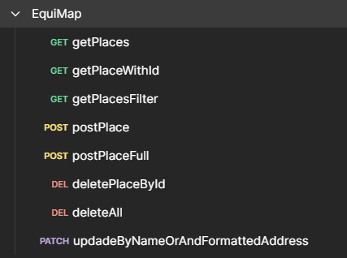
- Be extensive to accommodate future fields and locations.

Data model and table structure
The central entity in the database is the Place table. This table stores locations with each row representing an attribute including accessibility features or additional details. You can see full design in the 'Appendix F' section later in this document.

Data types and limitation
Primary Key: idPlace (auto-increment)
Required fields (on insert; help to identify specific place): name, formattedAddress, latitude, longitude
Boolean logic: all flags (e.g., acceptsCashOnly, wheelchairAccessibleParking) are stored as TINYINT(1) values (0 for false, 1 for true)
Field flexibility: Most fields are nullable, allowing partial data for incomplete submissions. Adding a new feature or service (e.g., "braille menu available") only requires adding one new field.

Security Considerations

Database
- Input validation is handled both in the Python backend (Flask API) and MySQL schema level.
- The connection was secured via environment-stored credentials in config.json.
- All insert/update/delete endpoints are protected by method-specific logic to prevent accidental data loss.

Maps
For our app to be able to display maps it needs to be able to access the MapBox service, and doing so requires authentication tokens. Our app uses two of these tokens: a dev token for downloading the required libraries and resources, and an access token for accessing the map data. Storing these tokens in a secure manner is important, as MapBox is only free until a certain threshold of users and API calls. This means that if these access tokens became available freely, illegitimate users would be able to abuse them at our expense. For this reason, storing these tokens securely is important.
To store these tokens securely we decided to use a library called dotenv, which has allowed us to store these tokens in a special token file instead of storing it inline within our code. Doing this has allowed us to easily prevent these tokens from being committed and pushed to GitHub, as the token file could easily be added to the .gitignore file, blacklisting it from being published. It also allows us to quickly replace the tokens with newly generated versions in case of illegitimate access.
While the access token needs to be bundled with the app to allow it to fetch map data, storing these tokens within the token files has also allowed us to prevent the dev token from being bundled in within our app’s executable, which prevents unauthorized users from accessing it.
In addition to storing these tokens securely, we have made sure that these tokens only allow for access to the parts of the MapBox API our app uses. This means that even if these tokens were to be accessed by malicious users, they would not be able to access any unauthorized API endpoints or data.

Testing & quality assurance

Testing methodology (unit, integration, user testing)
EquiMap's testing methodology was developed to ensure functional reliability, inclusive design, and real-world usability, emphasising technical correctness and accessibility.
1. Unit Testing:
Unit tests validated isolated logic, including input validation of forms for login and signup (e.g., email formats, password requirements). These were carried out using Jest (for frontend React Native components).
2. Integration Testing:
Integration tests confirmed that Supabase authentication, database storage, and UI response flowed correctly. An example is testing if data inputted using the signup form was stored appropriately and accessible through subsequent login attempts.
3. User Testing:
Informal usability testing sessions were conducted internally and with test users to observe how individuals interacted with the app's accessibility features. Results from these tests enhanced aspects like touch target sizes, contrast levels, and screen reader compatibility.
4. End-to-End (E2E) Testing:
Manual tests were executed on physical Android devices and emulators, simulating complete user journeys. These included flows like:
1. Opening the app and signing up/logging in
2. Navigating to the map and interacting with filters
3. Returning to the menu and changing preferences

Summary of bugs, fixes, and performance improvements

Login and Sign-up
Key Bug & Fix. Failure to Log in and View the Map Page
1: Authentication Flow Failure
The login and signup breakdown were one of the main problems that arose during the creation of EquiMap. Because the app did not have authentication at first, users could not log in or access its interactive map or other prominent features. Without this feature, users were left on the login page with no logical way to continue, effectively stopping the app's main flow.

2. Initial Solution: To solve this, we integrated Supabase, a backend-as-a-service solution, to manage user authentication. We were able to integrate user session management, secure login and signup procedures, and secure user credential storage thanks to Supabase. After setting it up, we added checks for the authentication status and, upon successful login, redirected users to the map screen. In the local development environment, this solution performed as expected.

3. Environmental Inconsistencies as a Secondary Issue:
When we attempted to use the same authentication system on different device, we encountered issues. There were errors on one device and not the other. Users were not redirected as intended by the login and signup page. Unfortunately, this error was not resolved in time for the showcase due to our focus switching to priority tasks.

4. Final Decision:
Our group removed the authentication system from the final build used for the demo because the signup and login process was unreliable across devices and could crash during the demo. Furthermore, there was no database available to store this information. Removing this enabled us to demonstrate a reliable and working app without the risk of login failure interruptions during the demo. Being able to display the rest of the app without interruption, especially the accessibility mapping and filtering, was a sensible choice.

Enhancements in Performance:
Despite the removal of the signup and login features from the final build, the debugging and implementation process revealed several performance and development enhancements:
- Supabase Integration: Supabase was intended to be used as a foundation for production-grade expandable database. It would make secure login possible. Unfortunately, issues within development caused us to cut this feature.
- Increased Showcase Stability

Removing the authentication screens provided the final showcase with a more reliable, error-free user interface. This prevented unexpected errors or crashes that would have compromised the essential components of the app.

Map
To implement the map, we had to use the rnmapbox library. It’s a library which uses a custom React Native component which can be added to screens to render an interactive map. This would have greatly simplified the app’s development if it were not for the fact that, as of writing this, the library is severely out of date and is poorly documented. We considered switching to an alternative library. However, we found no other alternatives which were able to work with the MapBox service while still meeting our other requirements. Due to the many problems which arose from trying to integrate this library into our app we considered switching our framework from React Native to regular React, as both of those frameworks are similar, but we decided to not proceed with that plan due to time constraints.
One of the biggest problems we encountered while integrating this library into our project has been directly caused by the rnmapbox’s library being out of date, as it has not been updated to work with the latest versions of React Native. This caused many bugs and errors throughout most of the app’s development and has significantly slowed down the development of our app, as our project has been made to use the latest React Native version 0.79, while the latest version officially supported by the map library is 0.76. By the end of our app’s development, we managed to find a community-made patch for the rnmapbox library, which we applied using the patch-package and postinstall-postinstall tools (rnmapbox, 2025) (npm. 2023)(npm. 2020).
The second biggest issue we ran into when working with rnmapbox appeared when we attempted to compile the project. Rnmapbox and some of the other libraries we used have many dependencies, and most of these dependencies have their own dependencies. This means that when compiling the app, Expo creates many folders, some of which have long names. This meant that whenever we attempted to compile the app, the path to some folders and files would get longer than the maximum path length which Windows supports, which would result in the compilation process failing. To fix this issue, we had to start compiling the app from folders at the root of our computer’s disk, as doing so shortened the problematic file paths enough for the compilation process to proceed.
Another problem we encountered during the development has been inaccurate documentation of the library for the map’s markers. For the markers to properly interact with our maps they had to have been implemented through the marker system provided by the rnmapbox library. This library provides several different systems for drawing images and React components on top of the map. However, each of these systems has its own features and limitations. We initially attempted to use the library’s dedicated marker system, but the markers created through this system could not be interacted with despite the documentation claiming otherwise, and they also caused flickering and other graphical issues whenever the map has been interacted with. For this reason, as well as the marker system’s poor performance, we were forced to switch to a different system. Whilst this new system has improved our app’s performance and allowed us to properly implement interactive markers, it has also prevented us from implementing several accessibility features such as hiding or highlighting nearby markers to make them easier to interact with.
The rnmapbox library also has several limitations, which have slowed down the development of our app. The most impactful of these limitations has been its requirement to be compiled to a device’s native code. This would prevent us from deploying the app to work as a web app, and it has also prevented us from using the Expo Go app to speed up the app’s development.
The library doesn’t provide the option to disable the rendering of certain features. The MapBox service provides its users with the ability to customise the map’s appearance. We originally planned on adjusting the map’s appearance to better suit the needs of our target audience. However, adding a custom MapBox style to our map through rnmapbox is not well documented and always enables rendering of all buildings and objects on the map in 3D. We determined that rendering the map in 3D would be too distracting and disruptive to people with visual impairments, and as we couldn’t disable them in our custom styles, we decided to keep the default map style provided by MapBox.

Featured menu
In addition to the interactive map, the main screen also has a drop-down menu at the bottom of the screen which displays to the user the featured locations the app recommends based on the user’s selected accessibility needs. This menu needs to be easily accessible from the main screen of the app. However, implementing it has proved challenging. This is because this menu would have to display on top of the interactive map which cannot be easily resized. We also wanted this menu to be hidden by default and only show up when the user attempts to interact with it, and this has caused several bugs we needed to resolve.
The biggest problem we had with this menu has been its positioning. We intended for this menu to be hidden near the bottom of the screen and fill out the screen with its options when it is interacted with. The need for us to manually control the menu’s position has often resulted in the menu being obstructed by the phone’s built-in navigation buttons or being positioned off-screen. We managed to solve this problem by using the React-Native-Safe-Area-Context library which let us know how much space these built-in navigation controls take place, and by how many pixels the menu and its buttons need to be offset by to be visible (npm. 2025).
Another issue we ran into while working on the list of featured locations was the images having different dimensions. The differently sized images have been causing the map screen to be displayed incorrectly. To remedy this issue, we decided to use one of the functions of the React framework which allows for prefetching the dimensions of images before those images are rendered on the screen. With this function we were able to make our app resize the images so that they all had the same width, while allowing them to change their height to preserve the original image’s aspect ratio. While this fix has left the heights of the images inconsistent, it has allowed the app to properly display all images without any visual artifacts. We determined that the confusion caused by the variable height would be negligible as we already planned for the menu to be scrollable vertically, and so it would be a trade-off for preserving the images and their quality.

Place
Hardcoded Photo Paths
During early integration of image assets, we discovered that the photo paths retrieved from the Google API were not direct URLs to hosted images, but rather to an API call which would fetch the image. This would have been no problem, as we would simply need to request for an image before displaying it. However, we were not sure how many different calls this would make to the API since we had the map and filter page which in theory displays all our photos. Since there was also a cost to calling Google’s API after a certain number of free calls, and we didn’t want to spend any of our budget here if we could help it, we decided to hardcode the images. Given the constraints, hardcoding the images was the most practical workaround since we only had around fifty entries in the database and an upcoming showcase. Of course, this limited the functionality of our app into displaying the images which we already gathered through an API or scraper. However, this was only a workaround and not how we would launch the app.
Price Level Type Mismatch
An input-related bug occurred when the price_level attribute was created as a number, which was not immediately flagged as an error in Visual Studio Code. Early during development when we were choosing which items to include in our database, we added price_level since we knew this was something we could take from the Google API. However, when we added this, we assumed it would be a number. It turns out that Google only has three different prices, one for each pound sign which is next to a location, and this is stored as one of three specific strings. The fix was simple: it was changed to the correct variable type in the code and the database.
Layout and Structural Refinements
During development of the “place screen”, the main interface for displaying detailed information about a location, we made all database variables accessible on the front end. This approach provided a high degree of flexibility, allowing for rapid testing and changing. However, it also introduced design challenges, particularly because we were working from only rough layout outlines with complete freedom on how to display information.
One such challenge involved the “wheelchairAccessibleDescription” field. Unlike the simple Boolean “wheelchairAccessibleEntrance” indicator, this field was intended to hold a paragraph describing in detail how accessible a venue is. The problem was not technical implementation, but rather UI and UX integration. It didn’t fit naturally with the binary accessibility indicators, yet placing it with general information like name or address made it appear out of place and inconsistent.
After revisiting the database, it became clear that this field was entirely empty across all entries. With no meaningful data to support its inclusion and no clear way to integrate it effectively into the UI, the field was removed from the front end to reduce unnecessary complexity.
UI Styling Adjustments (Finalisation Phase)
As part of the app finalisation process, several visual elements were refined. Notably, the styling of buttons was modified to remove unintended white boxes that appeared around interactive elements. This required updates to global CSS as well as component-scoped styles to ensure a consistent look across different screen sizes and states. Additional CSS edits were also made to improve padding, font hierarchy, and visual consistency throughout the application.
Integration of Custom Components
Each page was initially written using the built-in components which we were able to use by importing them using import statements. When finalising the application, we needed to rewrite all of these to use our custom components. These we would import into different screens by referencing their location within our app and then swap out with their corresponding elements. For example, <P> would be used instead of <Text>.
Incorporating custom-built components into the existing application structure introduced a couple different problems. Several components required refactoring to be more modular and reusable. Furthermore, implementation of one of the container components which was used haphazardly before, caused issues with the resizing of the screen when the opening hours button was clicked. Ultimately, this was fixed by removing and reshuffling the “ScrollView” component, and in the end our use of custom components helped add to the functionality of our app by allowing us to demonstrate using a text-to-speech reader at the showcase.
Problems with text reader
During the showcase, when we were demonstrating the screenreader, we found it was picking up the emojis we used to identify categories of information and reading them aloud. This was a problem since it would read out phrases like “dogface” when it reached the buttons. To fix this, we added specific names for each button, so that it would ignore the button content and read out our custom phrase. It now reads out “sustainability”, which is much more in-line with the category of information we were displaying.

Settings
The Settings screen was tested iteratively during development, with key focus areas being theme switching, user preference persistence, and cross-page state synchronisation. Testing methods included manual exploratory testing, component-level validation, and data persistence verification using AsyncStorage.
Area | Tested for
Theme Switching | Correct rendering of UI after changing between IBM and Tol palettes
AsyncStorage Integration | Persistent storage and retrieval of both theme and accessibility settings
Component Styling | Real-time reflection of theme changes on all custom components
Accessibility Filters | Accurate toggle functionality and proper sync with Filter page
Dark/Light modes | The app supports automatic dark/light mode detection based on device’s settings and adapts to them

Bug description | Status | Notes
Theme switching only updated Settings screen; other screens were ignored during MVP stage of the page | Fixed | Introduced useTheme hook to apply theme globally through context
Accessibility options/settings not persisted between code versions | Fixed | Integrated AsyncStorage with default fallback loading in useEffect()
Filter page did not reflect saved accessibility settings from Settings screen | Fixed | Issue occurred after late-stage update; resolved via shared storage and refactoring

Performance Improvements:
- Refactored State handling. Simplified state updates with a functional setAccessibilityOptions callback to prevent async side-effects.
- Optimised storage logic. Moved AsyncStorage functionality inside toggle functionality to ensure the smallest updates.
- Reduced code duplication. Used Object.entries() to map and render switches for accessibility filters dynamically.

Filter page
The layout was altered to have a singular column which would improve user experience and make everything more visible as opposed to the original two column layout.
The distance slider was removed as it would not interact with the database correctly as the database had coordinates and there was no user distance. This was later adjusted with a hardcoded user location and a distance function would use the place and user coordinates to calculate the distance from one another. The hardcoding can be replaced to a variable using live user location like the map provides for future iterations.
Due to the narrow range of ratings in the database, a “top-rated” filter was added instead of a 5-scale star filter. As there were not many locations, most were 4 stars and up therefore the scale filter would be mostly useless if it allowed people to select 2 or 3 stars (why would someone want to go to a 2-star place anyways?). This top-rated displayed places 4-stars and up and interacted with the database better than the former choice. The parameters set initially would not send all the required information to the place page, so this information from the database was then added to the code, which allowed a smooth transfer of data from one screen to another.
Similarly, when pressing on a location it should have taken the user to the place page for that location, but it did not. This was due to the outdated use of link tags, fixing this was done by defining each location card with TouchableOpacity to allow for proper interactions following react native documentation meaning they would act more like large buttons whilst also adhering to the pre-determined component styling.

Menu
Due to constant changing of pages and new additions, there were periods where the menu screen buttons would not go to the right screen and instead the URL at the top would be altered to reach the right page. It caused some friction where it was unclear which screens were meant to be in the app however, this was easily adjusted once final versions of screens were implemented where the buttons would all go to the target screen.
During early/mid stages of development most coding was done through the web version of the application and did not use a phone or emulator. As a result, all buttons used link tags but when switching to the actual application version this nullified the buttons. To fix this, the buttons used router tags to properly navigate to the correct screens when pressed. This screen was necessary during development for navigation through the app but became redundant in the final version and was removed.
There was no way of getting to the settings page from the menu which negatively impacted the user experience. A settings cog wheel icon was added in the top-right to adhere to general familiarity and have icon consistency throughout the app.

Results from user feedback
These are possible improvements and extensions for our project. They are based on the feedback we gathered throughout the project and at the showcase.
Overall, response to the app was positive with common comments being “this would be useful for someone I know” and “why isn’t this an app already?” This clearly highlights the usefulness of the project and how people could see/experience the benefits of its existence. Similarly, one person found a place on the app that they wanted to host a birthday celebration at; the information provided by our app aided her in planning and made understanding the accessibility easier. The showcase greatly emphasised that the two main elements of the project were met (making planning easier and combining a wide variety of accessibility information).
Although, testing through students and the showcase was quite successful, it was not without faults. Few enquired about the lack of navigation implementation and suggested it would be very useful to the app in the future. In the current scope of the project this would have been quite difficult but, for later versions adding navigation which caters routes to specific needs (e.g. mobility scooters) would be a great addition especially since the consensus is that Bath is not an accessible city. Keeping on the theme of expansion, it was commonly requested that the app should hold information for more locations which shows a gap in the market for accessibility, especially in architecturally older towns/cities so this would be something to attempt as well. Due to the design of the database and scraper this could be done and would not pose too great of a challenge.
Similarly, many struggled to see their current location in the app due to zooming and pin size so after receiving this feedback the default zoom was adjusted and a button to quickly pan the camera to user location was added. We had a lot of feedback pertaining to the search button. This was a feature we were already planning to implement, but we didn’t have time for. This means, like the expansion of the data, we have developed with this in mind, and it should be an easy feature to implement in the future.

User Documentation

User interface overview
The interface aims to be easy to see and to use. Text colours and backgrounds were carefully chosen to adhere to industry standards (see Appendix H) similar to the reasoning behind various font sizing (button text 16, subtext 16, titles 24-28, etc.). There are constant components ensuring consistency amongst place cards, icon sizing and overall padding/layouts as differing styling throughout the app would appear less professional and reduce the user experience.
We knew that there would be buttons on each page which do certain things, but these changed multiple times during development. For the final version of our product, there are buttons which link to settings, go back to the previous page, and even bring up a list of filters. The final version ensured all buttons present were essential due to the constant revisiting/revising of the app.

How to use features
On start-up the user will find themselves on the map screen which is interactive. If they lose track of where they are and want to find their location on the map, they can press the “you are here” button which will pan the camera to the user’s location pin. Furthermore, they can open the featured bar to see a handful of featured locations and clicking them will take the user to a screen holding more information about that place. We have accessibility emblems on said screen which can be interacted with by the user to reveal additional information such as “is good for children” or “guide dog friendly”.
The settings can be navigated to from every screen and its features are based on creating presets to reduce the effort needed by the user to find what they want. Profiles like “wheelchair user” and “socially anxious” can be applied and will then apply specific search filters to only show places that would cater to such users. Also, there is a choice of colour palettes to cater to a variety of inhibited colour vision users.
Another feature present is the filter that can be applied to find locations that are accessible in that context like “wheelchair accessible restroom” and “accepts contactless payment”. This reduces the amount of work the user does as they can only show ones they want rather than look through them manually and find ones they want.

Tips on the Use of EquiMap
EquiMap is designed to be a user-friendly app with accessibility as the main focus. We noticed during the showcase that a lot of the features were intuitive to users, thanks the layout of the app as well as the standardised implementation. The following are helpful tips on how users can better utilise the application:

1. First, Set Up Accessibility Preferences. On your first launch, go to the settings page to customise your accessibility experience. You can select different preferences such as a colour scheme that is colour-blind aware or personalised filters. These are saved settings, so you only must set them once.

2. Utilise the Map Screen for Quick Discovery. The map screen shows you your location with key accessible places in Bath:
- Touch interactive pins to view brief information on places.
- Drag up the recommended list from the bottom menu for tailored recommendations.

3. Use Smart Filters for Custom Results. Utilise the Filter Screen to:
- Search for venues with wheelchair access, induction loops, or quiet rooms.
- Toggle filters dynamically according to your requirements today.
- Utilise settings-based filters for even more tailored results.

4. Find Out Details via the Place Info Screen. Tap on a place to discover a full info screen where users can:
- View general information such as address, opening times, and contact information.
- Swipe down menus to learn about accessibility features, payment methods, and customer reviews.
- See only one dropdown at a time to minimise screen clutter.

5. Enjoy Accessible Navigation Aids. The app has accessibility at its core:
- All interactive elements are significant and easy to tap, helping users with impaired motor control.
- UI conventions are followed by the design so that navigation is easy.
- High-contrast display settings enhance readability in all lighting conditions.

6. Plan in Confidence
- Plan tours around Bath from home with the app.
- Verify accessibility data prior to visiting to avoid surprises.
- Featured destinations will make revisiting easy.

By following these tips, users can browse, plan, and experience Bath more easily. EquiMap is constantly being developed, and user suggestions are part of its ongoing development process.

Brief product history
Originally, we had planned for our app to be a web app due to the lack of native map libraries available to us. We spent a couple of weeks researching into this option. Ultimately, we decided to move back to Expo because switching to a web app would make all of our previous code redundant and incompatible. Furthermore, we managed to resolve the issue with our mapbox.
Throughout development, there were a few screens which were cut from the final version of the app. These were:
- Welcome
- Login
- Sign up
- Menu
- Initial (Debugging)
Some of these screens were cut due to time constraints but for the most part these were lost because they were development-only screens. Furthermore, the database which would support the “login” and “sign-up” screen wasn’t implemented so these screens were not necessary. We also didn’t have any functionalities yet that would require to store user’s information.

Mobile app’s development history
During our app’s development, the methods we used for running and testing our app have changed over time. When we started this project, our app did not have any libraries which require native code to be compiled, which has allowed us to use the Expo Go app. The Expo Go app hosts our code in the form of a website which we can access on our phones by scanning a QR code. This has allowed us to quickly prototype early versions of our app, as the Expo Go app would update itself with new versions of our code whenever we made any changes.
We tried several libraries for rendering the map. However, most of them were either severely out of date or did not meet our feature requirements. During our initial testing we were also unable to compile a version of our app which used rnmapbox. For this reason, we decided to test if any of the map libraries available for the web would be able to meet our requirements. This would require us to update our existing code to work without Expo and the React Native framework. However, as we were still in the early stages of the app’s development, we decided that testing alternative approaches to implementing the interactive map would still be worth it, and it would still be possible for us to either integrate the web libraries such as Leaflet into our app, or rewrite our code to not depend on React Native at this stage of development (Leaflet 2019). Reworking our app to work as a web app instead of a native app would also allow us to easily test and debug our code, as running our app in the web browser would give us access to additional debugging tools.
We quickly determined that this approach would limit us too much, as it would prevent our app from being deployed directly on our user’s devices. For this reason, we resumed our testing with React Native libraries, and after doing further testing on rnmapbox we were successful in integrating it into our app. With rnmapbox we were able to display interactive maps of Bath to the user. However, using this library in our app has prevented us from using the Expo Go app for debugging purposes as rnmapbox requires a native version of our app to function. We managed to get around this problem by changing our workflow to account for this limitation. We began compiling a native version of our app through Expo & Android Studio, which allowed us to maintain access to most of our debugging tools (Android Studio, 2019).

Project management & collaboration
Development methodology
There are different methodologies which teams can use to develop products. Some of the major options are Agile and Waterfall. In the end, we chose to use the Agile Scrum methodology. We chose this method because we needed to have regular weekly meeting to gain constant information from different team members. We knew that our application would need constant updates and tweaks to the design. Agile lets us do little bits at a time to simultaneously develop over different parts of the project, which let us split up our work causing less issues with dependencies.
Waterfall also allows for development without dependency issues. However, we didn't think a focus on planning would go well with our group since we anticipated many development problems due to the lack of experience within the team. And Agile is much more flexible in this situation.
On average, we had two meetings per week, with the first meeting of a week the start of a sprint, and the second meeting was a review on the progress of the sprint and setting new tasks. This was to fit in with different schedules and constraints each member of the team had. We have standup meetings which promotes interactivity within the team. This increased awareness of what each member is doing improves communication as well as progress due to the huge amount of help we were able to give one another.
It ensures constant progress due to the small consistent goals. In practice, an individual would be doing only one task each sprint. This means there is a focus on quality work each week and lower risk of negatively impacting the overall product. Also, the bugs which we accumulate were less severe, due to the small update system.
Another bonus of using Scrum methodology is that we were able to quickly gather and respond to feedback from testers. Sometimes, this feedback provided insight into errors which everyone on the team had missed and gave us a better understanding of how our users will interact with our application.

Tools used
We used certain tools to help us with development.
GitHub provided us with tools to easily manage the flow of the group’s work by letting us combine different branches into master. Here is the link to the GitHub repository of our project: https://github.com/XoToM/InnovationLabGroupProject
- Branches. It was standard practice to create a new branch for each task an individual had. This would let us easily detect and quarantine errors with broken code.
- Pull request. We’ve made it standard practice to merge our code into the main branch by creating pull requests. We had set reviewers to do a test merge on their local device to see if any given merge would cause additional errors. If not, the merge was carried out, and we continued development with the most up to date code.
- GitIgnore. There are a lot of files which are generic or unimportant. We added these to the GitIgnore file which declutters the GitHub repository and prevents confidential files from being committed to our public repository.

Trello is a very beneficial tool in Agile development due to its ability to create structured layouts to project plans whilst enabling collaboration in real-time.
- Backlog list is a place where we stored the main goals for each step of our project. This means we know where the project is heading.
- In progress tasks are moved here when we start working on them so that each group member is aware of the others’ progress. Each member should only have one task assigned to them at once.
- Lists for each sprint. Tasks are moved here once they are finished to generate a history of each task with key details such as the dates and times for when they were completed. This enables group assessment of workloads and to see if the next iterative cycle requires more or less complex tasks.

As a team, we used Discord for any and all general communications (Discord, 2015). The features we took advantage of most are the server team calls, and the team chats. Of course, direct messaging is also supported, but this is a supplementary feature for our purposes. Furthermore, there is an online status for each member of the team. This meant we knew when people were online which allowed us to assist other members regularly and with ease.

Roles of team members
We split the roles for each team member on their individual ability and experience. Of course, the team was able to discuss where they felt they had better or worse experience than we had judged. However, due to the small team size and the scale of the problem, there wasn’t much wiggle room in terms of tasks we needed to assign. Kate had experience and was confident she could design the database. Similarly, Dawid was aware of the different coding technique to design a smartphone app so was assigned to create the skeleton of the project. These team members were happy to do these parts due to their experience. Another core aspect of the app was web scraping. Since we all knew that this would be a huge part of our app, and nobody had any experience here, we decided that two team members would work together on this (Max and Elvin). Ali, being the final member, was given a task to work on the design of some of the pages and complete unit testing.
As the project progressed, the different roles for each team member changed and adapted to the different scenarios and problems which arose. This will be explained further in the individual contribution section.

Project Review & Reflection - Max
The first task we all had was to create a barebone version of the screens we were working on during the concept phase. For me, that was the “Place” screen. This was quickly done, just so that we had something to start developing with. Quickly, we moved on to our other tasks. We divided the workload so that different people were able to work to their strengths. In general, we didn’t have rigid team roles since we all had to be relatively fluid and accept tasks which we were not experts in. Near the start of the project, Elvin and I were assigned to web scraping, which we had assumed would be the main way we gather data to feed into our database. Neither of us were knowledgeable on how to do this, so we spent a lot of the first few weeks researching and trying different methods. This was not the most efficient way of doing this and we both wasted some time before settling on the appropriate ways we would go forward with our tasks.
In hindsight, we should have spent a good amount of time deciding on the exact method we would both use in the first week so that we could have started right away with gathering information. Ultimately, this didn’t significantly affect our final application, since we had enough information on the app for it to be useful to our users. But, knowing that we had plans from the start to easily be able to expand out from Bath, we gathered our data in a way that futureproofed it. This is because of the change I made to go from web scraping to API data collection. The main benefit of this was that I was able to gather specific data based on the name of a location. During development, I told Elvin that this would be how it worked, and he was able to focus on gathering additional information about accessibility information. Without this additional information, the information I was gathering from the Google API would be insufficient, since it didn’t contain much in the way of accessibility (our apps focus) and wouldn’t offer our users’ anything extra than what they could get from Google.
So, Elvin and I were working very closely with the data collection during the first part of our application development. Once Elvin had gathered his data from VisitBath, we decided that it would be sufficient, and he moved on to other aspects of the application. It was decided that I would manage entering all the data into the database. This meant combining it all so that it matched up, as well as gathering specific data based on the places Elvin was able to gather accessible information from. Luckily, the use of the API allowed me to identify by name, each place, and gather general information about them. Once I had all the information in JSON objects, I was able to merge them and add them to our database. This process was tricky, I had to write some scripts to merge and post different bits of data to the database.
With a final version of the information available to us, I was able to help Kate with the different datatypes within the database. I could tell Kate which new fields should be added, and which fields were completely empty, and could safely be disregarded. This ensured our database was kept clean and to the point. The scripts I wrote directly accessed and manipulated the database which Kate was overseeing. She was a great help during this stage of development. Not only would she make new commands which helped me greatly, such as the “delete all” command, but she made herself available with general questions on accessing her database at any time. The “delete all” command was added to Kate’s Postman which I was already using to write my scripts (they directly integrate with her database to run tasks such as “getPlaceWithId” or “postPlace”). This was a collaborative effort with my scripts. For example, I made a script which I used (Appendix Q) to repopulate the entire database on the (frequent) occasion we had an error occur with the data and needed to wipe the entire database.

Kate also helped me setup the emulator when it was time for me to continue developing on the “Place” screen. Overall, this took us around three hours of collaborative work to install the emulator which proved essential to my ability to work on the live version of the app, unimpeded.

Finally, once all the information was added to the database and we were all happy with it (there were still unexpected changes to come), I pivoted to working on the “Place” page, which I had previously written a barebones skeleton for, at the start of the project. I was responsible for developing this page because I had a great understanding of the information we had collected at this point, and the “Place” page was where we were displaying this information. I started by importing all the information and trying to display it on the screen, before focusing on the layout and visual hierarchy. To import the data to my screen, I had to work closely with Kate and Elvin. Due to the nature of the app, a user would need to enter my page through either the list of places, or the map screen. Therefore, these parts of the app needed to send my page the data which relates to the location a user is interested in. Luckily, for most of this development, I was able to set default values for a fake place and display this so that I could develop the “Place” screen without interrupting my teams’ workflow. Ultimately, we had a lot of information to display, so I decided that a lot of the accessible information would be categorised and summarised neatly so that it didn’t clutter the screen. Any general information about the place would be featured on the screen. For example, the name of the place would be in the header.
We had an image for each place which came from the Google API. Unfortunately, these were not links to actual hosted images, rather links to an API call which loaded the images. Due to the nature of the API, and more specifically their payment thresholds, we decided to hardcode these images ourselves so that we would be ready for the showcase. Elvin and I split this task which made it less tedious and sped up the process. This was the right decision, as a working version of our app was ready for the presentation. If we were to launch EquiMap as a product, we would need to efficiently gather these images and perhaps even store them in our database.
Dawid managing the security tokens. I had given him my token so that he could ensure it was stored securely. However, in the end I decided it should be completely removed once we had hardcoded the images.
At the end of development, we needed to reformat the entire application to work with our custom components created by Dawid and Kate. Doing this for the “Place” page was my task and went mostly straightforward, except for the issue which broke the “open hours” button (previously discussed) which I was able to fix. This proved worth the effort since it allowed us to showcase a text reader working with our app.

Finally, during the presentation, we worked particularly well as a team. Overall, I was pleased with everyone’s effort here. Dawid was able to talk in depth about the technical aspect of our app which paired nicely with Kate, Elvin and I who were able to talk more generally about the use case of our app, who it helps the most, and how we expect to improve for the future.

Engagement and Contribution

Attendance at Innovation Lab sessions
We had two meetings per week. Elvin, Kate, Dawid and I were in attendance for each meeting. There were exceptional circumstances which sometimes prevented people from partaking in the meetings. However, we worked together as a team using our Discord communication channels to overcome these problems and continue collaboration. Closer towards the deadline of the showcase and the submission we had other meetings which were more sporadic. This demonstrates our team’s ability to adapt to the different situations and circumstances we had.

Additional input

Weekly meetings
During the weekly meetings, I was able to write up a summary of the progression of the team. This was useful since it provided us with a history of how the app was developed, let us identify problem areas which we could step in and help individuals with, and give us a clear idea of where we were heading for the following week.

Managing team members
During development, we had some issues with team members clashing for multiple reasons. Usually, this was a difference in opinion for which approach they each believed we should choose. Whilst I don’t claim to have managed these team members to resolve their issues, I do believe I contributed to moderating these problems and sustaining a healthy team environment. This culminated in Dawid taking it upon himself to rewrite the entire application right before the showcase. To his credit, he pulled it off. However, it was not the best display of teamwork, which upset other members of the team, myself included.

Other Small Contributions
During the late stages of development, my GitHub stopped working correctly. We decided, after troubleshooting the most common problems, to prioritise development and Kate and Dawid agreed to help me out with further pushes I needed to make to improve the code. I didn’t notice this problem earlier due to my tendency to commit directly to GitHub.
Dawid helped fix a couple small CSS changes which needed doing when he was working on the final version of our product.
I helped manage the presentation, agreeing with my team to all dress up smart. I was able to build some simple marketing material stands for our presentation out of wood, and I brought in some snacks to entice people to our stall.

Reflection
Based on the objectives we set ourselves in the first semester (Appendix R), I believe we have achieved what we set out to do.

Particularly, in scalability, which we worked hard as a team to prioritise. If we had a third semester, and were to continue working on this application, it would be simple to do, thanks to our scalable product.
Furthermore, the target audience has been maintained and the things we sought to cater to them for have been implemented. This was a major part since the project is built around being accessible.

References
Richardson, L. (2024) Beautiful Soup. Available at: https://www.crummy.com/software/BeautifulSoup/ (Accessed: 20 May 2025).
Guidelines (WCAG) 2.1. Available at: https://www.w3.org/TR/WCAG21/ (Accessed: 19/05/2025).
Postman. (2025). Postman API Platform. Postman v11.36.0. Available at: https://www.postman.com/api-platform/api-documentation/ (Accessed: 17 May 2025).
PythonAnywhere. (2025). PythonAnywhere Cloud-based Python Environment. Available at: https://www.pythonanywhere.com/ (Accessed: 17 May 2025).
Brown, S. (2025). C4 Model for Visualising Software Architecture. Available at: https://c4model.com/ (Accessed: 17 May 2025).
Oracle Corporation. (2025). MySQL Database Management System. Version 8. Available at: https://www.mysql.com/ (Accessed: 17 May 2025).
ScrapeGraphAI (2024). GitHub - ScrapeGraphAI/Scrapegraph-ai: Python scraper based on AI. [online] GitHub. Available at: https://github.com/ScrapeGraphAI/Scrapegraph-ai. (Accessed: 20 May 2025)
Visitbath.co.uk. (2019). Bath’s Official Tourism Site | Visit Bath. [online] Available at: https://visitbath.co.uk/. (Accessed: 20 May 2025)
Jest, 2025. Delightful JavaScript testing framework with a focus on simplicity. [online] Available at: https://jestjs.io/ [Accessed 20 May 2025].
React Native Testing Library, 2025. Testing utilities that encourage good testing practices for React Native apps. [online] Available at: https://testing-library.com/docs/react-native-testing-library/intro/ [Accessed 20 May 2025].
Supabase, 2025. Open source Firebase alternative – authentication, database, and storage. [online] Available at: https://supabase.com/ [Accessed 20 May 2025].
Supabase Auth API, 2025. API for managing user authentication and sessions in Supabase. [online] Available at: https://supabase.com/docs/guides/auth [Accessed 20 May 2025].
React Native (2024). React Native · A framework for building native apps using React. [online] reactnative.dev. Available at: https://reactnative.dev/.
Expo (n.d.). Expo. [online] Expo. Available at: https://expo.dev/.
npm. (n.d.). dotenv. [online] Available at: https://www.npmjs.com/package/dotenv.
rnmapbox (2025). fix(android): support RN 0.77 by efstathiosntonas · Pull Request #3749 · rnmapbox/maps. [online] GitHub. Available at: https://github.com/rnmapbox/maps/pull/3749 [Accessed 20 May 2025].
Meta Open Source (2025). React. [online] react.dev. Available at: https://react.dev/.
‌GitHub (2025). GitHub. [online] GitHub. Available at: https://github.com/.
Leaflet (2019). Leaflet — an open-source JavaScript library for interactive maps. [online] Leafletjs.com. Available at: https://leafletjs.com/.
Expo Documentation. (2024). Router. [online] Available at: https://docs.expo.dev/versions/latest/sdk/router/.
‌npm. (2023). patch-package. [online] Available at: https://www.npmjs.com/package/patch-package.
‌npm. (2020). postinstall-postinstall. [online] Available at: https://www.npmjs.com/package/postinstall-postinstall [Accessed 20 May 2025].
‌icons.expo.fyi. (n.d.). @expo/vector-icons directory. [online] Available at: https://icons.expo.fyi/Index.
npm. (2025). react-native-safe-area-context. [online] Available at: https://www.npmjs.com/package/react-native-safe-area-context.
Discord (2015). Discord — A New Way to Chat with Friends & Communities. [online] Discord. Available at: https://discord.com/
Android Studio (2019). Android Studio and SDK tools. [online] Android Developers. Available at: https://developer.android.com/studio

‌

‌
Appendices

C4 architecture diagram

Appendix A:

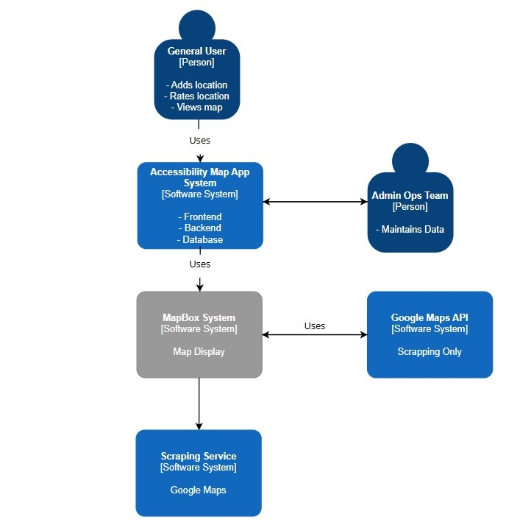

Appendix B:
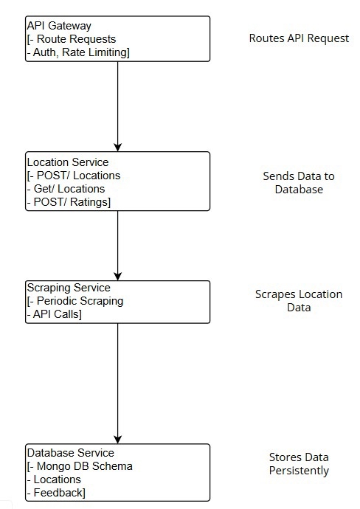

Appendix C:
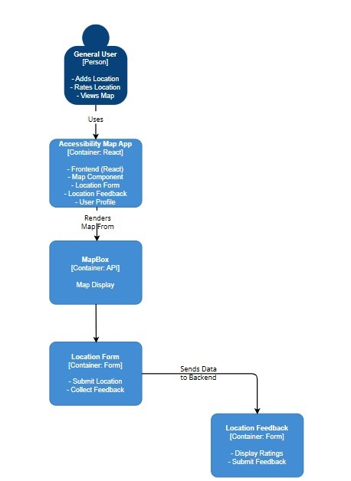

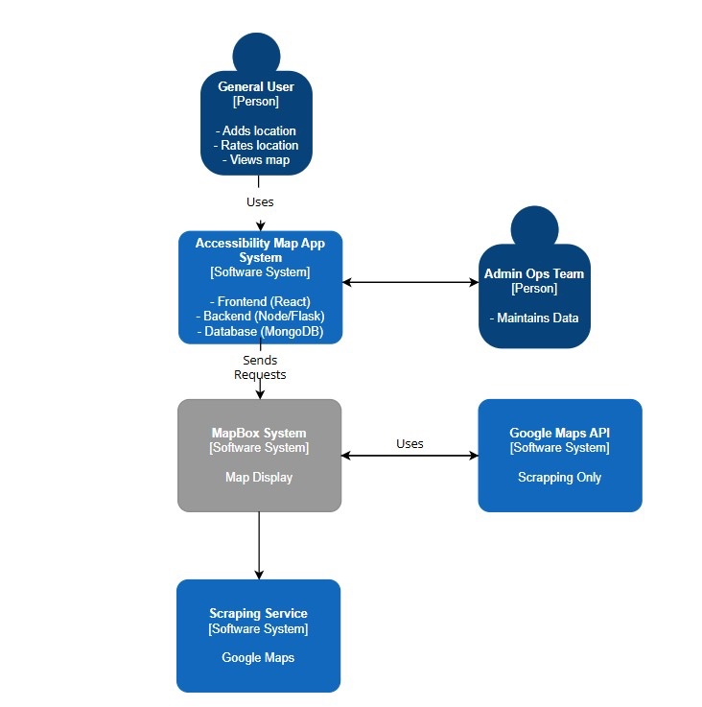
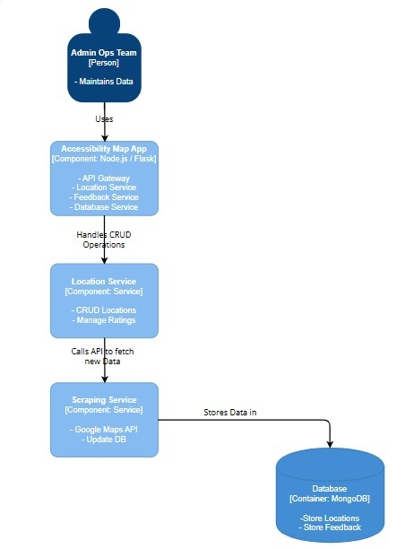

Appendix D: Table displaying Place database
(only key fields are displayed here, for full database screenshots and SQL code see below)
Field(s) | Type | Optional | Description
idPlace | INT, PK | No | Unique identifier for each place
name | VARCHAR(200) | No | Name of the place
formattedAddress | VARCHAR(500) | No | Full formatted address
latitude, longitude | FLOAT | No | Coordinates
wheelchairAccessableEnterence | TINYINT(1)* | Yes | Binary values indicating accessibility and service features
rating | TINYINT() | Yes | Users’ rating
priceLevel | VARCHAR(50) | Yes | Price level (can be INEXPENSIVE, MODERATE, VERY_EXPENSIVE)
photo | VARCHAR(5000) | Yes | Additional metadata
*Note: TINYINT(1) was used to represent Boolean logic, following MySQL standards, as native BOOLEAN type is not supported.

Appendix E: Example of how information is being stored in the database
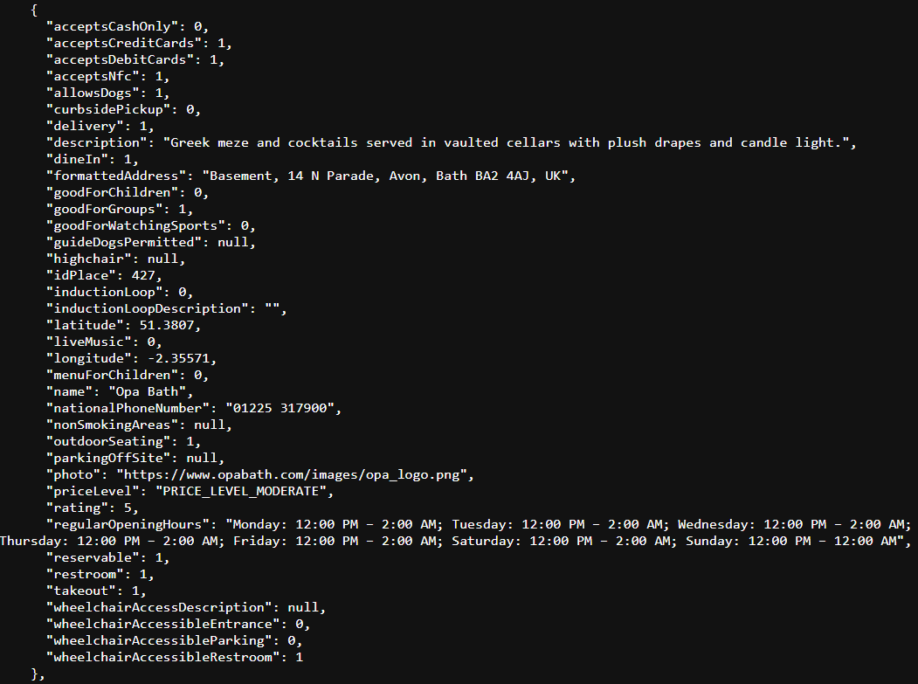

Appendix F: Database design
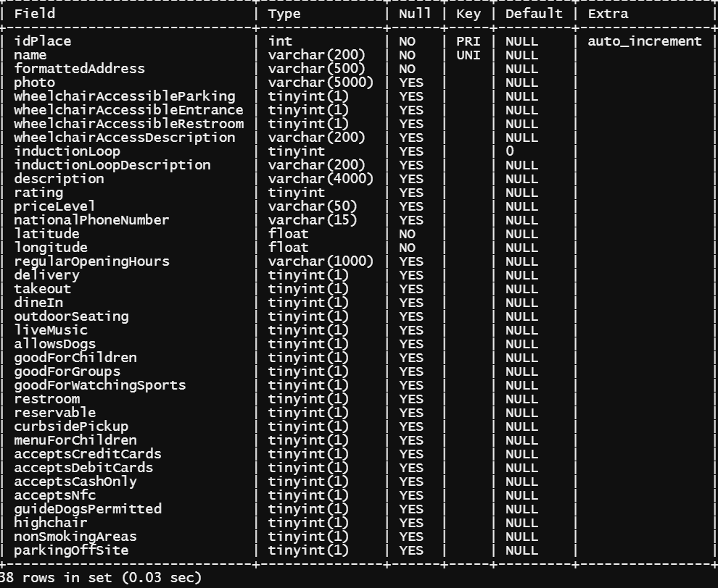

Appendix G: SQL code
-- MySQL Script generated by MySQL Workbench
-- Tue Apr 15 17:30:52 2025
-- Model: New Model Version: 1.0
-- MySQL Workbench Forward Engineering

SET @OLD_UNIQUE_CHECKS=@@UNIQUE_CHECKS, UNIQUE_CHECKS=0;
SET @OLD_FOREIGN_KEY_CHECKS=@@FOREIGN_KEY_CHECKS, FOREIGN_KEY_CHECKS=0;
SET @OLD_SQL_MODE=@@SQL_MODE, SQL_MODE='ONLY_FULL_GROUP_BY,STRICT_TRANS_TABLES,NO_ZERO_IN_DATE,NO_ZERO_DATE,ERROR_FOR_DIVISION_BY_ZERO,NO_ENGINE_SUBSTITUTION';

-- -----------------------------------------------------
-- Schema EquiMap
-- -----------------------------------------------------

-- -----------------------------------------------------
-- Schema EquiMap
-- -----------------------------------------------------
CREATE SCHEMA IF NOT EXISTS `EquiMap` DEFAULT CHARACTER SET utf8 ;
USE `EquiMap` ;

-- -----------------------------------------------------
-- Table `EquiMap`.`Place`
-- -----------------------------------------------------
DROP TABLE IF EXISTS `EquiMap`.`Place` ;

CREATE TABLE IF NOT EXISTS `EquiMap`.`Place` (
`idPlace` INT NOT NULL AUTO_INCREMENT,
`name` VARCHAR(200) NOT NULL,
`formattedAddress` VARCHAR(500) NOT NULL,
`photo` VARCHAR(5000) NULL,
`wheelchairAccessibleParking` TINYINT(1) NULL,
`wheelchairAccessibleEntrance` TINYINT(1) NULL,
`wheelchairAccessibleRestroom` TINYINT(1) NULL,
`wheelchairAccessDescription` VARCHAR(200) NULL,
`inductionLoop` TINYINT(1) NULL DEFAULT 0,
`inductionLoopDescription` VARCHAR(200) NULL,
`description` VARCHAR(4000) NULL,
`rating` TINYINT NULL COMMENT 'from 0 to 5, null - unknown;',
`priceLevel` VARCHAR(50) NULL,
`nationalPhoneNumber` VARCHAR(15) NULL,
`latitude` FLOAT NOT NULL,
`longitude` FLOAT NOT NULL,
`regularOpeningHours` VARCHAR(1000) NULL,
`delivery` TINYINT(1) NULL,
`takeout` TINYINT(1) NULL,
`dineIn` TINYINT(1) NULL,
`outdoorSeating` TINYINT(1) NULL,
`liveMusic` TINYINT(1) NULL,
`allowsDogs` TINYINT(1) NULL,
`goodForChildren` TINYINT(1) NULL,
`goodForGroups` TINYINT(1) NULL,
`goodForWatchingSports` TINYINT(1) NULL,
`restroom` TINYINT(1) NULL,
`reservable` TINYINT(1) NULL,
`curbsidePickup` TINYINT(1) NULL,
`menuForChildren` TINYINT(1) NULL,
`acceptsCreditCards` TINYINT(1) NULL,
`acceptsDebitCards` TINYINT(1) NULL,
`acceptsCashOnly` TINYINT(1) NULL,
`acceptsNfc` TINYINT(1) NULL,
`guideDogsPermitted` TINYINT(1) NULL,
`highchair` TINYINT(1) NULL,
`nonSmokingAreas` TINYINT(1) NULL,
`parkingOffSite` TINYINT(1) NULL,
PRIMARY KEY (`idPlace`),
UNIQUE INDEX `idPlace_UNIQUE` (`idPlace` ASC) VISIBLE,
UNIQUE INDEX `Name_UNIQUE` (`name` ASC) VISIBLE)
ENGINE = InnoDB;

SET SQL_MODE=@OLD_SQL_MODE;
SET FOREIGN_KEY_CHECKS=@OLD_FOREIGN_KEY_CHECKS;
SET UNIQUE_CHECKS=@OLD_UNIQUE_CHECKS;

Appendix H: Research design settings

Fonts
- Best universal fonts and accessibility. Fonts with simple, familiar shapes are generally easier to read.
  - Sans-serif fonts (no decorative strokes at the end of each letter):
    - Georgia (Gelasio for Google)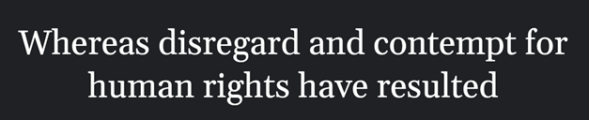
    - Helvetica (Open Sans for Google, Arial for Windows)
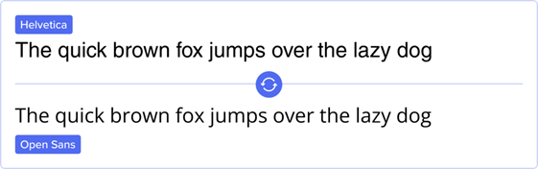

- Font size recommendations
  - Providing controls that allow users to incrementally change the size of all text up to 200 percent (check that after increasing the text size to 200% of the original size, there is no loss of content or functionality).
  - When a user adapts the page to increase the text spacing, text fits within the bounds of its containing box.
  - Bulleted and numbered lists are a very good way to present list content and set points apart.
  - Font sizes should never be less than the equivalent of 12 pixels.
  - Minimize inappropriate use of bold and italic fonts and also all-caps fonts are almost never appropriate and are very hard for some people to read.
  - Make sure there is enough spacing between characters.
  - As a rule, the line spacing should be set to the font size +6pt.
- Contrast and legibility. Make certain that product has good contrast. Contrast is the difference in color or density between the background and foreground (black on white is an example of good contrast, while purple on dark blue would surely result in poor contrast).
  - Links with a 3:1 contrast ratio with surrounding text with a white background. A blue color is recommended because it is affected very little by red and green color blindness (example).
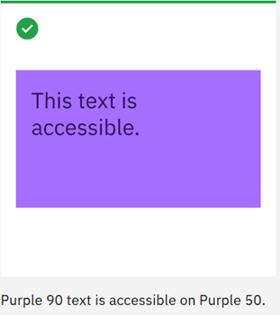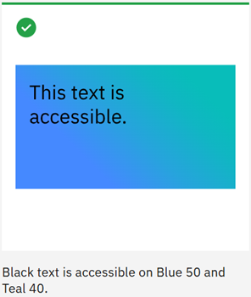
  - Text presented in an image is not accessible and must be described.
  - Animated (moving, wavy, blinking, etc.) text certainly needs to be avoided.

Color palettes
- Colorblind-friendly color schemes
  - Calm colors
    - Dark Blue: #332288
    - Green: #999933
    - Teal: #88CCEE
    - Light Blue: #44AA99
    - Yellow: #DDCC77
    - Orange: #117733
    - Pink: #CC6677
    - Purple: #AA4499
    - Maroon: #882255
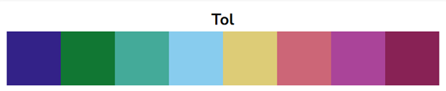
    - Background Colors
      - Dark blue, teal, light blue - provides a neutral and calming base, a soft and non-distracting look, gentle and clear base.
    - Icon Colors
      - Yellow, pink, orange - stand out well against darker backgrounds, drawing attention effectively.
      - Purple: Works well for icons, providing good visibility against lighter backgrounds.
    - Text Colors
      - Black: Best for text on lighter backgrounds, ensuring high readability.
      - White: Ideal for text on darker backgrounds, providing clear contrast.
    - Accent Colors
      - Green: Can be used for highlights and important areas, offering good visibility.
      - Maroon: Suitable for accents, providing a strong contrast.
  - Pairs:
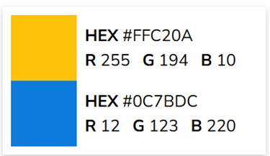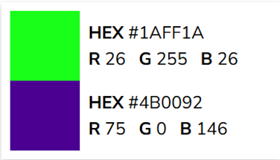
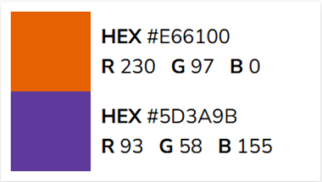
- High contrast color palettes
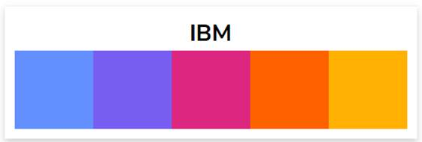
  - Blue (#648FFF): ideal for backgrounds and large areas due to its calming and neutral properties.
  - Purple (#785EF0): suitable for accents and highlights, as it stands out well against both light and dark backgrounds.
  - Pink (#DC267F): perfect for icons and important elements that need to draw attention.
  - Orange (#FE6100): great for icons and call-to-action elements, as it is vibrant and eye-catching.
  - Yellow (#FFB000): works well for highlights and accents, providing a bright and noticeable contrast.
  - White (#FFFFFF): best used for text and icons on dark (purple, orange) backgrounds, ensuring high readability.
  - Black (#000000): ideal for text and icons on light (blue, pink, yellow) backgrounds, providing clear and strong contrast.
- Avoiding problematic color combinations
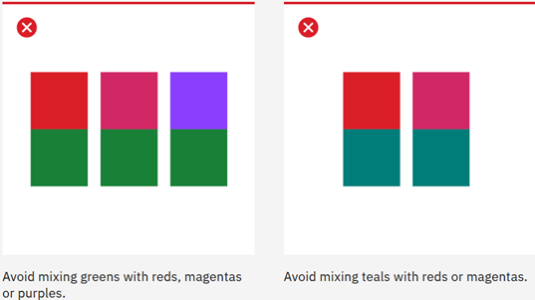
- Using patterns and textures
  - Do not contain anything that flashes more than three times in any one second period (not to cause seizures or physical reactions)

Icons
- Icon sizes for accessibility
  - Clickable icon should be at least 24×24 pixels
- Contrast and visibility of icons
  - Have widely used colors for almost immediate understanding of content of icon (for example red for canceling/deleting/exiting/invalid and green for go/okay/agree/valid buttons) (W3.org., 2024). But the product shouldn’t only rely on colors, the appropriate description is required (Riley-Huff, 2012).
- Icons for screen readers
  - Add tags to icons for screen readers to access

References

W3.org. (2024). Securely - Geolocation sharing. [online] Available at: https://www.w3.org/WAI/WCAG22/quickref/?showtechniques=134%2C141#use-of-color [Accessed 5 Dec. 2024].
Riley-Huff, D.A. (2012). Chapter 4: Web Accessibility and Universal Design. Library Technology Reports, [online] 48(7), pp.29–35. Available at: https://journals.ala.org/index.php/ltr/article/view/4687/5575.
Scope (2019). Home | Disability charity Scope UK. [online] Scope. Available at: https://www.scope.org.uk/.
Ibm.com. (2020). IBM Design Language – Color. [online] Available at: https://www.ibm.com/design/language/color/.
Nichols, D. (n.d.). Coloring for Colorblindness. [online] www.davidmathlogic.com. Available at: https://davidmathlogic.com/colorblind/#%23648FFF-%23785EF0-%23DC267F-%23FE6100-%23FFB000.
Collective, T.A. (2023). Improving Icon Usability and Accessibility: 6 Valuable Tips. [online] The A11Y Collective. Available at: https://www.a11y-collective.com/blog/icon-usability-and-accessibility/.
Google Developers (n.d.) Places API overview. Available at: https://developers.google.com/maps/documentation/places/web-service/overview (Accessed: 20 May 2025)

Appendix I: Filter Screen

import { AntDesign, Ionicons } from '@expo/vector-icons';
import AsyncStorage from '@react-native-async-storage/async-storage';
import { useRouter } from 'expo-router';
import React, { useEffect, useState } from 'react';
import { FlatList, Image, Modal, ScrollView, TouchableOpacity, View } from 'react-native';
import { useTheme } from '@/context/ThemeContext';
import BaseTheme from "@/constants/themes/base";

import { TextBtn, Toggle } from '@/components/interactive';
import { H2, P, Title } from '@/components/text';
import { BackgroundView, CardView } from '@/components/views';
import { SafeAreaView } from 'react-native-safe-area-context';

const router = useRouter()
const USER_LOCATION = {
latitude: 51.3781,
longitude: -2.3597,
};

type Place = {
distance: string;
longitude: number;
latitude: number;
idPlace: number;
name: string;
formattedAddress: string;
photo: string;
wheelchairAccessibleParking: number;
wheelchairAccessibleEntrance: number;
wheelchairAccessibleRestroom: number;
wheelchairAccessDescription: number;
description: string;
rating: number;
priceLevel: number;
nationalPhoneNumber: string;
regularOpeningHours: string;
delivery: number;
takeout: number;
dineIn: number;
outdoorSeating: number;
liveMusic: number;
allowsDogs: number;
goodForChildren: number;
goodForGroups: number;
goodForWatchingSports: number;
restroom: number;
reservable: number;
curbsidePickup: number;
menuForChildren: number;
acceptsCreditCards: number;
acceptsDebitCards: number;
acceptsCashOnly: number;
acceptsNfc: number;
};

type FilterKey =
| 'wheelchairAccessibleEntrance'
| 'wheelchairAccessibleParking'
| 'wheelchairAccessibleRestroom'
| 'allowsDogs'
| 'ratings'
| 'inductionLoop'
| 'goodForChildren'
| 'delivery'
| 'takeout'
| 'reservable'
| 'acceptsNfc'
| 'acceptsCashOnly';

type Filters = Record<FilterKey, boolean>;

// Map accessibility options to filter keys
const accessibilityToFilterMap: Partial<Record<keyof AccessibilityOptions, FilterKey>> = {
'Wheelchair user': 'wheelchairAccessibleEntrance',
'Guide dog owner': 'allowsDogs',
'Social anxiety': 'reservable'
};

type AccessibilityOptions = {
'Wheelchair user': boolean;
'Guide dog owner': boolean;
'Social anxiety': boolean;
};

function calculateDistance(lat1: number, lon1: number, lat2: number, lon2: number): string {
const R = 6371;
const dLat = (lat2 - lat1) * Math.PI / 180;
const dLon = (lon2 - lon1) * Math.PI / 180;
const a =
Math.sin(dLat / 2) * Math.sin(dLat / 2) +
Math.cos(lat1 * Math.PI / 180) *
Math.cos(lat2 * Math.PI / 180) *
Math.sin(dLon / 2) *
Math.sin(dLon / 2);
const c = 2 * Math.atan2(Math.sqrt(a), Math.sqrt(1 - a));
const distance = R * c;
return distance < 1 ? `${Math.round(distance * 1000)}m` : `${distance.toFixed(1)}km`;
}

export default function PlacesScreen() {
const theme = useTheme();
const [places, setPlaces] = useState<Place[]>([]);
const [loading, setLoading] = useState(true);
const [isModalVisible, setIsModalVisible] = useState(false);

const [filters, setFilters] = useState<Filters>({
wheelchairAccessibleEntrance: false,
wheelchairAccessibleParking: false,
wheelchairAccessibleRestroom: false,
allowsDogs: false,
ratings: false,
inductionLoop: false,
goodForChildren: false,
delivery: false,
takeout: false,
reservable: false,
acceptsNfc: false,
acceptsCashOnly: false,
});

const filterOptions: { key: FilterKey; label: string }[] = [
{ key: 'wheelchairAccessibleEntrance', label: 'Wheelchair Access Entrance' },
{ key: 'wheelchairAccessibleParking', label: 'Wheelchair Parking' },
{ key: 'wheelchairAccessibleRestroom', label: 'Wheelchair Access Restroom' },
{ key: 'allowsDogs', label: 'Dogs Allowed' },
{ key: 'ratings', label: 'Highly Rated' },
{ key: 'inductionLoop', label: 'Hearing Loop' },
{ key: 'goodForChildren', label: 'Child Friendly' },
{ key: 'delivery', label: 'Has delivery' },
{ key: 'takeout', label: 'Has takeout' },
{ key: 'reservable', label: 'Takes Reservations' },
{ key: 'acceptsNfc', label: 'Contactless Payment' },
{ key: 'acceptsCashOnly', label: 'Cash Payment' },
];

useEffect(() => {
const loadSettingsAndFetch = async () => {
try {
const savedOptions = await AsyncStorage.getItem('accessibilityOptions');
if (savedOptions) {
const parsedOptions: AccessibilityOptions = JSON.parse(savedOptions);
console.log('Loaded accessibility options:', parsedOptions);

// Map accessibility options to filters
const updatedFilters = { ...filters };
Object.entries(accessibilityToFilterMap).forEach(([accessibilityKey, filterKey]) => {
if (parsedOptions[accessibilityKey as keyof AccessibilityOptions]) {
updatedFilters[filterKey] = true;
}
});

console.log('Updated filters based on settings:', updatedFilters);
setFilters(updatedFilters);
await fetchPlaces(updatedFilters);
} else {
console.log('No accessibility options found, fetching with default filters');
await fetchPlaces();
}
} catch (error) {
console.error('Failed to load accessibility settings:', error);
await fetchPlaces();
}
};

loadSettingsAndFetch();
}, []);

const fetchPlaces = async (appliedFilters = filters) => {
const activeFilters = Object.entries(appliedFilters)
.filter(([key, value]) => key !== 'ratings' && value)
.map(([key]) => `${key}=1`);

if (appliedFilters.ratings) {
activeFilters.push('rating=4');
activeFilters.push('rating=4.5');
activeFilters.push('rating=5');
}

const queryString = activeFilters.length ? `?${activeFilters.join('&')}` : '';
const url = `https://katestudent.pythonanywhere.com:443/places${queryString}`;

try {
setLoading(true);
const response = await fetch(url);

if (!response.ok) {
const errorText = await response.text();
throw new Error(`Failed to fetch places: ${response.status} - ${errorText}`);
}

const data = await response.json();
const placesWithDistance = data.places.map((place: Place) => {
const distance = calculateDistance(
USER_LOCATION.latitude,
USER_LOCATION.longitude,
place.latitude,
place.longitude
);
return {
...place,
distance,
};
});

setPlaces(placesWithDistance);
} catch (err) {
console.error('❌ FETCH ERROR:', err);
} finally {
setLoading(false);
}
};

useEffect(() => {
fetchPlaces();
}, []);

const toggleFilter = async (key: FilterKey) => {
const newValue = !filters[key];
const updatedFilters = { ...filters, [key]: newValue };
setFilters(updatedFilters);
await fetchPlaces(updatedFilters);
};

const toggleModal = () => {
setIsModalVisible(!isModalVisible);
};

if (loading) {
return (
<BackgroundView style={{ justifyContent: 'center', alignItems: 'center' }}>
<P>Loading...</P>
</BackgroundView>
);
}

return (
<BackgroundView>
{/* <CardView style={{ flexDirection: 'row', justifyContent: 'space-between', alignItems: 'center', padding: 16 }}>

<TouchableOpacity style={{margin: 10}} onPress={() => router.back()}>
<Ionicons name="home" size={28} />
</TouchableOpacity>

<TouchableOpacity style={{margin: 10}} onPress={() => router.push('/screens/settings')}>
<Ionicons name="settings" size={28}/>
</TouchableOpacity>

</CardView> */}
<TextBtn onClick={toggleModal} style={{ paddingHorizontal: 15 }}>
Filters
</TextBtn>

<Modal
transparent={true}
animationType="slide"
visible={isModalVisible}
onRequestClose={toggleModal}
>
<View style={{ flex: 1, justifyContent: 'center', alignItems: 'center', backgroundColor: 'rgba(0, 0, 0, 0.5)' }}>
<CardView style={{ width: '80%', maxHeight: '70%', padding: 24 }}>
<View style={{flex:1,flexDirection:'row',justifyContent:"space-between"}}>
<Title style={{ marginBottom: 16 }}>Filters</Title>
<TouchableOpacity
onPress={toggleModal}
style={[BaseTheme.button,{ backgroundColor: theme.theme.primary,padding:5 }]}
>
<AntDesign name="close" size={48} color={theme.theme.text} />
</TouchableOpacity>
</View>

<ScrollView style={{ maxHeight: '80%' }}>
{filterOptions.map(({ key, label }) => (
<Toggle key={key} label={label} value={filters[key]} onChange={() => toggleFilter(key)} />
))}
</ScrollView>
</CardView>
</View>
</Modal>

<FlatList
data={places}
style={{ width: '100%', paddingHorizontal: 15 }}
contentContainerStyle={{ paddingBottom: 16 }}
keyExtractor={(item) => item.idPlace.toString()}
numColumns={1}
renderItem={({ item }) => (
<CardView style={{margin: 10}}>
<TouchableOpacity
onPress={() => router.push(
{
pathname: '/screens/place',
params: item
})}
>
{item.photo && (
<Image
source={{ uri: item.photo }}
style={{ width: '100%', height: 150, borderRadius: 8, marginBottom: 10 }}
resizeMode="cover"
/>
)}
<H2 style={{ textAlign: 'center' }}>{item.name}</H2>
<P style={{ textAlign: 'center' }}>{item.formattedAddress}</P>
<P style={{ textAlign: 'center', marginTop: 5 }}>
{`${item.distance} away`}
</P>
</TouchableOpacity>
</CardView>
)}
/>
</BackgroundView>
);
}

Appendix J: Place place

import { H1, H2, H3, P } from '@/components/text';
import { BackgroundView, CardView } from '@/components/views';
import { FontAwesome5, Ionicons } from '@expo/vector-icons';
import { useTheme } from '@react-navigation/native';
import { useLocalSearchParams, useRouter } from 'expo-router';
import React, { useState } from 'react';

import {
Image,
ScrollView,
StyleSheet,
TouchableOpacity,
View
} from 'react-native';
import { SafeAreaView, useSafeAreaInsets } from 'react-native-safe-area-context';
export default function App() {
const theme = useTheme();
const safeAreaPadding = useSafeAreaInsets();
const [activeInfo, setActiveInfo] = useState(null);
const [hoursOpen, setHoursOpen] = useState(false);
const { idPlace, name, formattedAddress, photo, wheelchairAccessibleParking, wheelchairAccessibleEntrance, wheelchairAccessibleRestroom, wheelchairAccessDescription, inductionLoop, inductionLoopDescription, description, rating, priceLevel, nationalPhoneNumber, latitude, longitude, regularOpeningHours, delivery, takeout, dineIn, outdoorSeating, liveMusic, allowsDogs, goodForChildren, goodForGroups, goodForWatchingSports, restroom, reservable, curbsidePickup, menuForChildren, acceptsCreditCards, acceptsDebitCards, acceptsCashOnly, acceptsNfc } = useLocalSearchParams(); //add additional parameters

const toggleInfo = (type: any) => {
setActiveInfo(activeInfo === type ? null : type);
};

const renderStars = (rating: any) => {
const fullStars = Math.floor(Number(rating));
const stars = [];

for (let i = 0; i < fullStars; i++) {
stars.push('⭐');
}
return stars.join('');
};

const renderPriceLevel = (priceLevel: string) => {
const map: { [key: string]: string } = {
PRICE_LEVEL_INEXPENSIVE: '£',
PRICE_LEVEL_MODERATE: '££',
PRICE_LEVEL_VERY_EXPENSIVE: '£££',
};
return map[priceLevel] || '???'; // Default to unknown if not found
};

return (
// <SafeAreaView edges={["bottom"]}>
<BackgroundView style={styles.container}>
<ScrollView style={styles.scrollContainer} contentContainerStyle={[styles.scrollContent,{paddingBottom:safeAreaPadding.bottom+10}]}> {/*you need scroll view to scroll but then you need background to make it look good. thats why its nested like this freaky deaky ass shit*/}

{photo ? (
<Image source={{ uri: String(photo) }} style={[styles.largeImage, { resizeMode: "stretch" }]} />
) : (
<P>No image available</P>
)}
<View style={{width:"90%", flex:1,flexDirection:"column",justifyContent:"center",alignItems:"center"}}>

<View style={[styles.buttonContainer,{marginBottom:0}]}>
{[
{ type: 'accessibility', label: ' ♿ ', accessibleLabel:"Movement Accessibility" },
{ type: 'familyPets', label: ' 🐶 ', accessibleLabel:"Suitability" },
{ type: 'services', label: ' 🍽️ ', accessibleLabel:"Available Services" },
{ type: 'payment', label: ' 💳 ', accessibleLabel:"Payment Methods" },
].map(({ type, label,accessibleLabel }) => (

<CardView key={type} style={[styles.buttonWrapper,(activeInfo===type)?{paddingBottom:0, borderBottomWidth:0}:{}]}>
<TouchableOpacity style={styles.iconButton} onPress={() => toggleInfo(type)}>
<P style={styles.iconText} accessibleLabel={accessibleLabel}>{String(label)}</P>
</TouchableOpacity>
{activeInfo === type && <P>▲</P>}
</CardView>
))}
</View>

{activeInfo&&(<CardView style={[styles.noticeBox,{maxHeight:activeInfo?"auto":0}]}>
{activeInfo === 'accessibility' && (
<>
<P>
{Number(wheelchairAccessibleEntrance) === 1 ? '✅ Accessible Entrance ✅' : '❌ No Accessible Entrance ❌'}
</P>
<P>
{Number(wheelchairAccessibleParking) === 1 ? '✅ Accessible Parking ✅' : '❌ No Accessible Parking ❌'}
</P>
<P>
{Number(wheelchairAccessibleRestroom) === 1 ? '✅ Accessible Restroom ✅' : '❌ No Accessible Restroom ❌'}
</P>
</> // wheelchair access description not even used at all in database and it was giving me a headache
)}

{activeInfo === 'familyPets' && (
<>
<P>
{Number(goodForChildren) === 1 ? '✅ Good for Children ✅' : '❌ Not Suitable for Children ❌'}
</P>
<P>
{Number(menuForChildren) === 1 ? '✅ Kids Menu Available ✅' : '❌ No Kids Menu ❌'}
</P>
<P>
{Number(restroom) === 1 ? '✅ Restroom Available ✅' : '❌ No Restroom ❌'}
</P>
<P>
{Number(goodForGroups) === 1 ? '✅ Good for Groups ✅' : '❌ Not Suitable for Groups ❌'}
</P>
<P>
{Number(allowsDogs) === 1 ? '✅ Dogs Allowed ✅' : '❌ No Dogs Allowed ❌'}
</P>
</>
)}

{activeInfo === 'services' && (
<>
<P>
{Number(delivery) === 1 ? '✅ Delivery Available ✅' : '❌ No Delivery ❌'}
</P>
<P>
{Number(takeout) === 1 ? '✅ Takeout Available ✅' : '❌ No Takeout ❌'}
</P>
<P>
{Number(dineIn) === 1 ? '✅ Dine-In Option ✅' : '❌ No Dine-In Option ❌'}
</P>
<P>
{Number(curbsidePickup) === 1 ? '✅ Curbside Pickup ✅' : '❌ No Curbside Pickup ❌'}
</P>
<P>
{Number(outdoorSeating) === 1 ? '✅ Outdoor Seating ✅' : '❌ No Outdoor Seating ❌'}
</P>
<P>
{Number(liveMusic) === 1 ? '✅ Live Music ✅' : '❌ No Live Music ❌'}
</P>
<P>
{Number(goodForWatchingSports) === 1 ? '✅ Good for Watching Sports ✅' : '❌ Not Suitable for Watching Sports ❌'}
</P>
<P>
{Number(reservable) === 1 ? '✅ Can Be Reserved ✅' : '❌ Not Reservable ❌'}
</P>
</>

)}

{activeInfo === 'payment' && (
<>
<P>
{Number(acceptsCreditCards) === 1 ? '✅ Accepts Credit Cards ✅' : '❌ Does Not Accept Credit Cards ❌'}
</P>
<P>
{Number(acceptsDebitCards) === 1 ? '✅ Accepts Debit Cards ✅' : '❌ Does Not Accept Debit Cards ❌'}
</P>
<P>
{Number(acceptsNfc) === 1 ? '✅ Contactless Payments Accepted ✅' : '❌ No Contactless Payments ❌'}
</P>
<P>
{Number(acceptsCashOnly) === 1 ? '✅ Cash Only ✅' : '❌ Cash & Cards ❌'}
</P>
</>
)}

</CardView>)}

</View>

<CardView style={styles.ratingContainer}>
<P style={styles.stars}>{renderStars(rating)}</P>

<P>{renderPriceLevel(Array.isArray(priceLevel) ? priceLevel[0] : priceLevel)}</P>
</CardView>

{description && (
<CardView style={styles.ratingContainer}>
<H3>{String(description)}</H3>
</CardView>
)}

{formattedAddress && (
<CardView style={[styles.ratingContainer,{alignItems:"center"}]}>
<FontAwesome5 name="building" size={20} color="black" style={styles.labelIcons} /><H3>{String(formattedAddress)}</H3>
</CardView>
)}
{nationalPhoneNumber && (
<CardView style={[styles.ratingContainer,{alignItems:"baseline"}]}>
<FontAwesome5 name="phone-alt" size={20} color="black" style={styles.labelIcons} /><H3>{String(nationalPhoneNumber)}</H3>
</CardView>
)}

{regularOpeningHours && (
<CardView style={styles.hoursBox}>
<TouchableOpacity onPress={() => setHoursOpen(!hoursOpen)} style={styles.dropdownButton}>
<H3 style={{textAlign:"center"}}>{hoursOpen ? '▲ Hide Opening Hours ▲' : '▼ Show Opening Hours ▼'}</H3>
</TouchableOpacity>

{hoursOpen &&
String(regularOpeningHours)
.split(/[\n;|]+/)
.map((line, index) => (
<P key={index} style={styles.contactText}>
{line.trim()}
</P>
))}
</CardView>
)}
</ScrollView>
</BackgroundView>
// </SafeAreaView>
);

}

const styles = StyleSheet.create({

scrollContainer: {
flex: 1,
flexDirection:"column",
width: '100%',
height: "100%",
gap:20,
},

scrollContent: {
paddingVertical: 20,
alignItems: 'center',
width: '100%',
gap:10
},
container: {
flex: 1,
//backgroundColor: '#f5f5a3',
alignItems: 'center',
},
largeImage: {
width: '90%',
height: 200,
borderRadius: 10,
marginBottom:10
},
labelIcons:{
margin:5
},
buttonContainer: {
flexDirection: 'row',
gap: 10,
alignItems:"flex-start"
},
buttonWrapper: {
alignItems: 'center',
},
iconButton: {
backgroundColor: '#f8f8f8',
padding: 15,
borderRadius: 50,
elevation: 3,
},
iconText: {
fontSize: 20,
},
arrow: {
fontSize: 20,
marginTop: 5,
},
noticeBox: {
//backgroundColor: '#f4a261',
padding: 10,
borderRadius: 5,
width: '100%',
// width: '90%',
alignItems: 'center',
shadowOffset: {height:15,width:0}
},
noticeText: {
fontSize: 16,
fontWeight: 'bold',
textAlign: 'center',
},
ratingContainer: {
flexDirection: 'row',
justifyContent: 'space-between',
width: '90%',
alignItems: 'center',
},
contactText: {
fontSize: 14,
textAlign: 'left',
width: '90%',
},

dropdownButton: {
marginTop: 10,
marginBottom: 10,
alignSelf: 'flex-start',
paddingLeft: 20,
width:"100%"
},

dropdownText: {
fontSize: 14,
fontWeight: 'bold',
color: '#333',
},

hoursBox: {
width: '90%',
paddingHorizontal: 10,
paddingVertical: 6,
borderRadius: 8,
alignSelf: 'center',
textAlign:"center",
textAlignVertical:"center",
alignItems:"center",
justifyContent:"center"
//backgroundColor: '#ddd',
},
stars: {
fontSize: 18,
},
price: {
fontSize: 18,
fontWeight: 'bold',
},
description: {
fontSize: 14,
textAlign: 'center',
padding: 15,
},
modalContainer: {
flex: 1,
//backgroundColor: 'rgba(0, 0, 0, 0.5)', // Dark overlay
justifyContent: 'center',
alignItems: 'center',
},

menuTray: {
width: '90%',
height: '80%',
//backgroundColor: '#fff',
borderRadius: 10,
alignItems: 'center',
justifyContent: 'center',
padding: 20,
},
closeButton: {
position: 'absolute',
top: 20,
right: 20,
},
closeText: {
fontSize: 20,
color: '#333',
fontWeight: 'bold',
},

});

Appendix K: Settings page

import { Ionicons } from "@expo/vector-icons";
import AsyncStorage from "@react-native-async-storage/async-storage";
import { useRouter } from 'expo-router';
import React, { useEffect, useState } from "react";
import {
ScrollView,
StyleSheet,
Switch,
Text,
TouchableOpacity,
View,
} from "react-native";
import { useTheme } from "../../context/ThemeContext";

const router = useRouter();

type AccessibilityOptions = {
"Wheelchair user": boolean;
"Guide dog owner": boolean;
"Social anxiety": boolean;
};

const defaultAccessibilityOptions: AccessibilityOptions = {
"Wheelchair user": false,
"Guide dog owner": false,
"Social anxiety": false,
};

const SettingsScreen = () => {
const [accessibilityOptions, setAccessibilityOptions] = useState<AccessibilityOptions>(defaultAccessibilityOptions);
const { theme, paletteName, setPalette } = useTheme();

useEffect(() => {
const loadSettings = async () => {
try {
const savedOptions = await AsyncStorage.getItem("accessibilityOptions");
if (savedOptions) {
const parsedOptions = JSON.parse(savedOptions);
const validOptions = { ...defaultAccessibilityOptions };
Object.keys(defaultAccessibilityOptions).forEach((key) => {
if (parsedOptions.hasOwnProperty(key)) {
validOptions[key as keyof AccessibilityOptions] = !!parsedOptions[key];
}
});
setAccessibilityOptions(validOptions);
}
} catch (error) {
console.error("Failed to load settings:", error);
}
};

loadSettings();
}, []);

const toggleOption = async (option: keyof AccessibilityOptions) => {
setAccessibilityOptions((prev) => {
const updated = { ...prev, [option]: !prev[option] };
AsyncStorage.setItem("accessibilityOptions", JSON.stringify(updated)).catch((error) => {
console.error(`Failed to save accessibilityOptions:`, error);
});
return updated;
});
};

return (
<ScrollView style={[styles.container, { backgroundColor: theme.background }]}>
{/* <View style={styles.header}>
<TouchableOpacity style={styles.settingIcon} onPress={() => router.back()}>
<Ionicons name="home" size={28} color={theme.text} />
</TouchableOpacity>
<Text style={[styles.headerText, { color: theme.text }]}>Settings</Text>
<TouchableOpacity style={styles.settingIcon} onPress={() => router.push('/screens/filter-places')}>
<Ionicons name="close" size={28} color={theme.text} />
</TouchableOpacity>
</View> */}

{/* Accessibility Options */}
<View style={styles.section}>
<TouchableOpacity style={styles.settingIcon}>
<Ionicons name="accessibility" size={24} color={theme.text} />
</TouchableOpacity>
<View style={[styles.optionsContainer, { backgroundColor: theme.card }]}>
{Object.entries(accessibilityOptions).map(([key, value]) => (
<View key={key} style={styles.optionRow}>
<Switch value={value} onValueChange={() => toggleOption(key as keyof AccessibilityOptions)} accessibilityLabel={key} />
<Text style={[styles.sectionText, { color: theme.text }]} accessible={false}>{key}</Text>
</View>
))}
</View>
</View>

{/* Color Palette Selector */}
<View style={styles.section}>
<TouchableOpacity style={styles.settingIcon}>
<Ionicons name="color-palette" size={24} color={theme.text} />
</TouchableOpacity>
<View style={[styles.optionsContainer, { backgroundColor: theme.card }]}>
{(["IBM", "Tol"] as const).map((palette) => (
<TouchableOpacity
key={palette}
style={styles.optionRow}
onPress={() => setPalette(palette)}
>
<Switch
value={paletteName === palette}
onValueChange={() => setPalette(palette)}
/>
<Text style={[styles.sectionText, { color: theme.text }]}>{palette} color palette</Text>
</TouchableOpacity>
))}
</View>
</View>
</ScrollView>
);
};

const styles = StyleSheet.create({
container: {
flex: 1,
padding: 10,
},
header: {
flexDirection: "row",
justifyContent: "space-between",
alignItems: "center",
marginBottom: 10,
},
headerText: {
fontSize: 24,
fontWeight: "bold",
},
section: {
marginBottom: 10,
padding: 20,
width: "90%",
alignSelf: "center",
},
sectionText: {
marginLeft: 10,
fontSize: 16,
},
settingIcon: {
margin: 10,
},
optionsContainer: {
padding: 10,
borderRadius: 10,
},
optionRow: {
flexDirection: "row",
alignItems: "center",
marginVertical: 5,
},
});

export default SettingsScreen;

Appendix L: Map

import { Entypo } from '@expo/vector-icons';
// Causes warnings to appear. It looks like rnmapbox has quite a few bugs atm
import Mapbox, { Camera, LocationPuck, MapView, MarkerView, PointAnnotation } from "@rnmapbox/maps";
import Constants from 'expo-constants';
import { useRouter } from 'expo-router';
import React, { useEffect, useRef, useState } from 'react';
import { Animated, DimensionValue, FlatList, Image, StyleSheet, Text, TouchableOpacity, View } from 'react-native';

import { H1, H2 } from '@/components/text';
import { CardView } from '@/components/views';
import { useTheme } from '@/context/ThemeContext';
import * as Location from "expo-location";
import AntDesign from '@expo/vector-icons/AntDesign';
import { useSafeAreaInsets } from 'react-native-safe-area-context';

Location.requestForegroundPermissionsAsync();

if(Constants.expoConfig?.extra?.MAPBOX_ACCESS_TOKEN){
Mapbox.setAccessToken(Constants.expoConfig.extra.MAPBOX_ACCESS_TOKEN); // insert mapbox public token here
Mapbox.setTelemetryEnabled(false);
}

function LocationPreview({info}:any){
const [imageRatio, setImageRatio] = useState(1);
const router = useRouter();
useEffect(()=>{
Image.getSize(info.photo,(w,h)=>{
setImageRatio(w/h)
});
},[]);

return <TouchableOpacity onPress={()=>router.push({pathname:"/screens/place",params:info})} accessibilityLabel={info.name} accessible={true}>
<CardView style={{flex:1,flexDirection:"column",gap:20, padding:20}}>
<Image source={{
uri: info.photo,
}} style={{
width:"100%",
resizeMode:"contain",
aspectRatio:imageRatio
}}/>
<H2>{info.name}</H2>
</CardView>
</TouchableOpacity>
}

export default function ScreenMap() {
const router = useRouter();
const { theme } = useTheme();
const [prevShowMenu,setPrevShowMenu] = useState(true);
let animated_pos = new Animated.Value(-600);

let [showFeatured, setShowFeatured] = useState(true);
let safeAreaPadding = useSafeAreaInsets();
let featuredPos:DimensionValue = showFeatured?0:"-60%";

useEffect(()=>{
if(prevShowMenu.valueOf()){
setPrevShowMenu(false);
return;
}
console.log(Mapbox.StyleURL.Street);
if(showFeatured.valueOf()){
animated_pos.setValue(0);
Animated.timing(animated_pos, {
useNativeDriver: false,
toValue: -600+safeAreaPadding.bottom
}).start();
}else {
animated_pos.setValue(-600+safeAreaPadding.bottom);
Animated.timing(animated_pos, {
useNativeDriver: false,
toValue: 0
}).start();
}
},[showFeatured, animated_pos]);

let [locations, setLocations]:[any,any] = useState([]);
let locationsInfo = locations.slice(0,5);

function shuffle(arr:any[]){
for (let i=0;i<arr.length;i++){
let other = Math.floor(Math.random()*arr.length);
let tmp = arr[i];
arr[i] = arr[other];
arr[other] = tmp;
}
return arr;
}

useEffect(()=>{
fetch("https://katestudent.pythonanywhere.com:443/places").then(async (response)=>{
if (response.ok){
let data = await response.json();
let places = shuffle(data.places);
setLocations(places);
}else{
console.warn(`Failed to fetch recommended locations: ${await response.text()}`);
}
});
},[]);
//styleURL='mapbox://styles/qbit1103/cm8zw2f22005l01sd70eu9cve'
return (
<View style={{ flex: 1, alignItems: 'center', justifyContent: 'center' }}>
{Constants.expoConfig?.extra?.MAPBOX_ACCESS_TOKEN?(
<MapView style={StyleSheet.absoluteFillObject} compassEnabled={true} attributionPosition={{top: 32, left: 8}} logoPosition={{top: 32, left: 32}}>
<Camera defaultSettings={{ centerCoordinate: [-2.3643467114359953, 51.378860189408165], zoomLevel: 13 }}/>
{
locations.map((loc:any,i:number)=>{
return <PointAnnotation key={i + ">" + loc.name} id={"" + i} coordinate={[loc.longitude, loc.latitude]} anchor={{ x: 0.5, y: 1 }} onSelected={
() => router.push({
pathname: '/screens/place',
params: loc
})}>
<Entypo name="location-pin" size={48} color="green" />
</PointAnnotation>;
})
}
<LocationPuck visible={true} puckBearing='heading' puckBearingEnabled={true}/>
</MapView>):<Text style={StyleSheet.absoluteFillObject}>No tokens provided</Text>
}
<Animated.View style={{padding:10,position:"absolute",width:"100%", maxHeight:"90%", bottom:animated_pos, backgroundColor:theme.background}}>
<TouchableOpacity style={{ padding: 15, borderRadius: 50, elevation: 3,position:"absolute",marginLeft:5,marginTop:-64,backgroundColor:theme.background}}><Entypo name="location" size={24} color="black" /></TouchableOpacity>
<TouchableOpacity onPress={()=>{setShowFeatured(!showFeatured);}}>
<View style={{flex:1, flexDirection:'row', justifyContent:"space-between",paddingHorizontal:10}}>
<H1 style={{marginBottom:20}}>Featured</H1>
{
showFeatured?<AntDesign name="down" size={48} color="black" />:<AntDesign name="up" size={48} color="black" />
}
</View>
</TouchableOpacity>
<FlatList style={{padding:10}} contentContainerStyle={{gap:10}} scrollEnabled={true} horizontal={false} data={locationsInfo} renderItem={(i)=><LocationPreview info={i.item}/>} ItemSeparatorComponent={() => <View style={{height:1,width: 10}} />}/>
</Animated.View>
</View>
);
}

Appendix M:

import requests

def update_place(name, updates):
url = "https://katestudent.pythonanywhere.com:443/places"
headers = {"Content-Type": "application/json"}

try:
query_params = {"name": name}
get_url = requests.Request('GET', url, params=query_params).prepare().url
current_response = requests.get(get_url, headers=headers)

if current_response.status_code != 200:
print(f"❌ Failed to fetch current data for {name}. Status: {current_response.status_code}")
return

current_data = current_response.json()
if isinstance(current_data, list) and current_data:
current_data = current_data[0]
elif isinstance(current_data, list):
print(f"ℹ️ No existing record for {name}.")
return

# Filter updates to only include meaningful changes
filtered_updates = {
key: value for key, value in updates.items()
if current_data.get(key) != value
}

if not filtered_updates:
print(f"ℹ️ No meaningful updates needed for {name}.")
return

patch_url = requests.Request('PATCH', url, params=query_params).prepare().url
patch_response = requests.patch(patch_url, json=filtered_updates, headers=headers)

if patch_response.status_code == 200:
print(f"✅ Successfully updated {name}")
else:
print(f"❌ Failed to update {name}. Status: {patch_response.status_code}")
print(patch_response.text)

except requests.exceptions.RequestException as e:
print(f"Error updating {name}: {str(e)}")

# Example usage:
update_place("Corkage Bath", {
"photo": "https://www.corkagebath.com/wp-content/uploads/2023/01/resataurant.jpeg"
})

Appendix N:

import requests

places = [
{
"name": "Green Park Brasserie",
"guideDogsPermitted": 1,
"highchair": 1,
"nonSmokingAreas": 1,
"parkingOffSite": 1,
"allowsDogs": 1,
"menuForChildren": 1,
"goodForGroups": 1
},
{
"name": "Eat A Pitta - Bath",
"guideDogsPermitted": 0,
"highchair": 1,
"nonSmokingAreas": 0,
"parkingOffSite": 0,
"allowsDogs": 1,
"menuForChildren": 0,
"goodForGroups": 1
},
{
"name": "The Elder Restaurant",
"guideDogsPermitted": 0,
"highchair": 0,
"nonSmokingAreas": 0,
"parkingOffSite": 0,
"allowsDogs": 1,
"menuForChildren": 0,
"goodForGroups": 0
},
{
"name": "Chew Valley Distillery",
"guideDogsPermitted": 0,
"highchair": 0,
"nonSmokingAreas": 0,
"parkingOffSite": 0,
"allowsDogs": 1,
"menuForChildren": 0,
"goodForGroups": 1
},
{
"name": "Abbey Hotel Bath, a Tribute Portfolio Hotel",
"guideDogsPermitted": 0,
"highchair": 1,
"nonSmokingAreas": 0,
"parkingOffSite": 0,
"allowsDogs": 1,
"menuForChildren": 1,
"goodForGroups": 0
},
{
"name": "LEON Bath",
"guideDogsPermitted": 0,
"highchair": 1,
"nonSmokingAreas": 0,
"parkingOffSite": 0,
"allowsDogs": 1,
"menuForChildren": 1,
"goodForGroups": 0
},
{
"name": "Bath Pizza Co",
"guideDogsPermitted": 0,
"highchair": 1,
"nonSmokingAreas": 0,
"parkingOffSite": 0,
"allowsDogs": 1,
"menuForChildren": 0,
"goodForGroups": 1
},
{
"name": "The Pump Room Restaurant",
"guideDogsPermitted": 0,
"highchair": 0,
"nonSmokingAreas": 0,
"parkingOffSite": 0,
"allowsDogs": 0,
"menuForChildren": 0,
"goodForGroups": 0
},
{
"name": "Flourish CSR",
"guideDogsPermitted": 0,
"highchair": 1,
"nonSmokingAreas": 0,
"parkingOffSite": 0,
"allowsDogs": 1,
"menuForChildren": 1,
"goodForGroups": 0
},
{
"name": "The Gainsborough Bath Spa",
"guideDogsPermitted": 0,
"highchair": 0,
"nonSmokingAreas": 0,
"parkingOffSite": 0,
"allowsDogs": 1,
"menuForChildren": 0,
"goodForGroups": 0
},
{
"name": "The Bath Stable",
"guideDogsPermitted": 0,
"highchair": 1,
"nonSmokingAreas": 0,
"parkingOffSite": 0,
"allowsDogs": 1,
"menuForChildren": 1,
"goodForGroups": 0
},
{
"name": "The Bath Townhouse",
"guideDogsPermitted": 0,
"highchair": 1,
"nonSmokingAreas": 0,
"parkingOffSite": 0,
"allowsDogs": 1,
"menuForChildren": 1,
"goodForGroups": 0
},
{
"name": "Bandook - Indian Restaurant, Bath",
"guideDogsPermitted": 0,
"highchair": 1,
"nonSmokingAreas": 0,
"parkingOffSite": 0,
"allowsDogs": 0,
"menuForChildren": 0,
"goodForGroups": 0
},
{
"name": "Bath Cider House",
"guideDogsPermitted": 0,
"highchair": 0,
"nonSmokingAreas": 0,
"parkingOffSite": 0,
"allowsDogs": 1,
"menuForChildren": 0,
"goodForGroups": 0
},
{
"name": "Bowood Hotel, Spa & Golf Resort",
"guideDogsPermitted": 0,
"highchair": 1,
"nonSmokingAreas": 0,
"parkingOffSite": 0,
"allowsDogs": 0,
"menuForChildren": 0,
"goodForGroups": 0
},
{
"name": "The Gainsborough Bath Spa",
"guideDogsPermitted": 0,
"highchair": 1,
"nonSmokingAreas": 0,
"parkingOffSite": 0,
"allowsDogs": 0,
"menuForChildren": 0,
"goodForGroups": 0
},
{
"name": "Flourish at Farleigh Road",
"guideDogsPermitted": 0,
"highchair": 1,
"nonSmokingAreas": 0,
"parkingOffSite": 0,
"allowsDogs": 1,
"menuForChildren": 1,
"goodForGroups": 0
},
{
"name": "The Cork",
"guideDogsPermitted": 0,
"highchair": 0,
"nonSmokingAreas": 0,
"parkingOffSite": 0,
"allowsDogs": 0,
"menuForChildren": 0,
"goodForGroups": 0
},
{
"name": "Olive Tree Restaurant",
"guideDogsPermitted": 0,
"highchair": 0,
"nonSmokingAreas": 0,
"parkingOffSite": 0,
"allowsDogs": 0,
"menuForChildren": 0,
"goodForGroups": 0
},
{
"name": "Woodchester Valley Vineyard",
"guideDogsPermitted": 0,
"highchair": 0,
"nonSmokingAreas": 0,
"parkingOffSite": 0,
"allowsDogs": 1,
"menuForChildren": 0,
"goodForGroups": 0
},
{
"name": "Apex City of Bath Hotel",
"guideDogsPermitted": 0,
"highchair": 0,
"nonSmokingAreas": 0,
"parkingOffSite": 0,
"allowsDogs": 0,
"menuForChildren": 0,
"goodForGroups": 0
},
{
"name": "Corkage Bath",
"guideDogsPermitted": 0,
"highchair": 1,
"nonSmokingAreas": 0,
"parkingOffSite": 0,
"allowsDogs": 1,
"menuForChildren": 0,
"goodForGroups": 0
},
{
"name": "The Beefy Boys - Bath",
"guideDogsPermitted": 0,
"highchair": 1,
"nonSmokingAreas": 0,
"parkingOffSite": 0,
"allowsDogs": 1,
"menuForChildren": 1,
"goodForGroups": 0
},
{
"name": "Brasserie Beau",
"guideDogsPermitted": 0,
"highchair": 1,
"nonSmokingAreas": 0,
"parkingOffSite": 0,
"allowsDogs": 1,
"menuForChildren": 1,
"goodForGroups": 0
},
{
"name": "The Langford Inn",
"guideDogsPermitted": 0,
"highchair": 1,
"nonSmokingAreas": 0,
"parkingOffSite": 0,
"allowsDogs": 1,
"menuForChildren": 1,
"goodForGroups": 0
},
{
"name": "Bath Brew House",
"guideDogsPermitted": 0,
"highchair": 1,
"nonSmokingAreas": 0,
"parkingOffSite": 0,
"allowsDogs": 0,
"menuForChildren": 1,
"goodForGroups": 0
},
{
"name": "Newton Farm Shop & Cafe",
"guideDogsPermitted": 0,
"highchair": 0,
"nonSmokingAreas": 0,
"parkingOffSite": 0,
"allowsDogs": 0,
"menuForChildren": 0,
"goodForGroups": 0
}
]

url = "https://katestudent.pythonanywhere.com:443/places"
headers = {"Content-Type": "application/json"}

for place in places:
try:
if "name" not in place:
print(f"Skipping entry with missing name: {place}")
continue

name = place["name"]
query_params = {"name": name}

# GET current data for this place
get_url = requests.Request('GET', url, params=query_params).prepare().url
current_response = requests.get(get_url, headers=headers)

if current_response.status_code != 200:
print(f"Failed to fetch current data for {name}. Status: {current_response.status_code}")
continue

current_data = current_response.json()
if isinstance(current_data, list) and current_data:
current_data = current_data[0]
elif isinstance(current_data, list):
print(f"No existing record for {name}. Skipping.")
continue

# Build update payload with ONLY meaningful upgrades
update_payload = {
key: value
for key, value in place.items()
if key != "name" and (
current_data.get(key) in [None, "", 0] and value == 1
)
}

if not update_payload:
print(f"No updates needed for {name}.")
continue

# Send PATCH request with filtered payload
patch_url = requests.Request('PATCH', url, params=query_params).prepare().url
patch_response = requests.patch(patch_url, json=update_payload, headers=headers)

if patch_response.status_code == 200:
print(f"✅ Successfully updated {name}")
else:
print(f"❌ Failed to update {name}. Status: {patch_response.status_code}")
print(patch_response.text)

except requests.exceptions.RequestException as e:
print(f"Error updating {place.get('name', 'Unknown')}: {str(e)}")

print("Finished updating all places.")

Appendix O

import json

# Load JSON from file
with open("afternoon-tea-at-the-gainsborough-bath-spa-.json", "r", encoding="utf-8") as file:
data = json.load(file)

# Extract relevant details
filtered_results = []
for place in data.get("places", []):
filtered_results.append({
# KEY INFORMATION (Main Details)
"name": place.get("displayName", {}).get("text", "No Name"),
"formattedAddress": place.get("formattedAddress", "No Address"),
"nationalPhoneNumber": place.get("nationalPhoneNumber", "No Phone"),
"rating": place.get("rating", "No Rating"),
"userRatingCount": place.get("userRatingCount", "No User Ratings"),
"googleMapsUri": place.get("googleMapsUri", "No Link"),
"websiteUri": place.get("websiteUri", "No Website"),
"priceLevel": place.get("priceLevel", "No Price Level"),
"priceRange": place.get("priceRange", "No Price Range"),
"businessStatus": place.get("businessStatus", "No Status"),

# ADDITIONAL DETAILS (Services & Amenities)
"regularOpeningHours": place.get("regularOpeningHours", {}).get("weekdayDescriptions", "No Hours"),
"currentOpeningHours": place.get("currentOpeningHours", {}).get("weekdayDescriptions", "No Current Hours"),
"servesBreakfast": place.get("servesBreakfast", False),
"servesLunch": place.get("servesLunch", False),
"servesDinner": place.get("servesDinner", False),
"servesBrunch": place.get("servesBrunch", False),
"servesDessert": place.get("servesDessert", False),
"servesCoffee": place.get("servesCoffee", False),
"servesCocktails": place.get("servesCocktails", False),
"servesBeer": place.get("servesBeer", False),
"servesWine": place.get("servesWine", False),
"takeout": place.get("takeout", False),
"delivery": place.get("delivery", False),
"dineIn": place.get("dineIn", False),
"outdoorSeating": place.get("outdoorSeating", False),
"liveMusic": place.get("liveMusic", False),
"allowsDogs": place.get("allowsDogs", False),
"goodForChildren": place.get("goodForChildren", False),
"goodForGroups": place.get("goodForGroups", False),
"goodForWatchingSports": place.get("goodForWatchingSports", False),
"restroom": place.get("restroom", False),
"reservable": place.get("reservable", False),
"curbsidePickup": place.get("curbsidePickup", False),
"menuForChildren": place.get("menuForChildren", False),
"paymentOptions": place.get("paymentOptions", []),
"parkingOptions": place.get("parkingOptions", []),
"accessibilityOptions": place.get("accessibilityOptions", {}),

# 🔍 METADATA & EXTRA INFO

})

# Print the clean output
print(json.dumps(filtered_results, indent=2))

# "id": place.get("id", "No ID"),
# "types": place.get("types", []),
# "primaryType": place.get("primaryType", "No Primary Type"),
# "primaryTypeDisplayName": place.get("primaryTypeDisplayName", "No Type Display Name"),
# "shortFormattedAddress": place.get("shortFormattedAddress", "No Short Address"),
# "addressComponents": place.get("addressComponents", []),
# "plusCode": place.get("plusCode", {}),
# "location": place.get("location", {}),
# "viewport": place.get("viewport", {}),
# "utcOffsetMinutes": place.get("utcOffsetMinutes", "No UTC Offset"),
# "adrFormatAddress": place.get("adrFormatAddress", "No ADR Address"),
# "iconMaskBaseUri": place.get("iconMaskBaseUri", "No Icon"),
# "iconBackgroundColor": place.get("iconBackgroundColor", "No Color"),
# "editorialSummary": place.get("editorialSummary", {}).get("text", "No Summary"),
# "googleMapsLinks": place.get("googleMapsLinks", {}),
# "addressDescriptor": place.get("addressDescriptor", "No Address Descriptor"),
# "timeZone": place.get("timeZone", "No Time Zone"),
# "reviews": place.get("reviews", []),
# "photos": place.get("photos", [])

Appendix P
import json
import requests

with open("response18.json", "r", encoding="utf-8") as file:

data = json.load(file)
print("Loaded JSON successfully. Keys:", list(data.keys()))

url = "https://katestudent.pythonanywhere.com:443/places"
headers = {"Content-Type": "application/json"}

def extract_place(place):
return {
"name": place.get("displayName", {}).get("text", ""),
"formattedAddress": place.get("formattedAddress", ""),
"photo": place.get("photos", [{}])[0].get("googleMapsUri", None),
"wheelchairAccessibleParking": int(place.get("accessibilityOptions", {}).get("wheelchairAccessibleParking", False)),
"wheelchairAccessibleEntrance": int(place.get("accessibilityOptions", {}).get("wheelchairAccessibleEntrance", False)),
"wheelchairAccessibleRestroom": int(place.get("restroom", False)), # assumed this implies accessible restroom
"wheelchairAccessDescription": None, # no such description found in file
"inductionLoop": 0, # not present in JSON
"inductionLoopDescription": "", # not present in JSON
"description": place.get("editorialSummary", {}).get("text", None),
"rating": round(place.get("rating", 0)) if "rating" in place else None,
"priceLevel": place.get("priceLevel", None), # e.g., "PRICE_LEVEL_MODERATE"
"nationalPhoneNumber": place.get("nationalPhoneNumber", None),
"latitude": place.get("location", {}).get("latitude", None),
"longitude": place.get("location", {}).get("longitude", None),
"regularOpeningHours": "; ".join(place.get("regularOpeningHours", {}).get("weekdayDescriptions", [])),
"delivery": int(place.get("delivery", False)),
"takeout": int(place.get("takeout", False)),
"dineIn": int(place.get("dineIn", False)),
"outdoorSeating": int(place.get("outdoorSeating", False)),
"liveMusic": int(place.get("liveMusic", False)),
"allowsDogs": int(place.get("allowsDogs", False)),
"goodForChildren": int(place.get("goodForChildren", False)),
"goodForGroups": int(place.get("goodForGroups", False)),
"goodForWatchingSports": int(place.get("goodForWatchingSports", False)),
"restroom": int(place.get("restroom", False)),
"reservable": int(place.get("reservable", False)),
"curbsidePickup": 0, # not present in JSON
"menuForChildren": int(place.get("menuForChildren", False)),
"acceptsCreditCards": int(place.get("paymentOptions", {}).get("acceptsCreditCards", False)),
"acceptsDebitCards": int(place.get("paymentOptions", {}).get("acceptsDebitCards", False)),
"acceptsCashOnly": int(place.get("paymentOptions", {}).get("acceptsCashOnly", False)),
"acceptsNfc": int(place.get("paymentOptions", {}).get("acceptsNfc", False)),
}

for place in data["places"]:
try:
place_payload = extract_place(place)
response = requests.post(url, json=place_payload, headers=headers)

if response.status_code == 201:
print(f"Successfully added {place_payload['name']}")
else:
print(f"Failed to add {place_payload['name']}. Status code: {response.status_code}")
print(f"Response: {response.text}")

except Exception as e:
print(f"Error processing place: {place.get('name', 'Unknown')}, error: {str(e)}")

print("Finished sending all places.")

Appendix Q
import json
import requests

# Load the original checkpoint JSON
with open("after take 2.json", "r", encoding="utf-8") as file:
data = json.load(file)

url = "https://katestudent.pythonanywhere.com:443/places"
headers = {"Content-Type": "application/json"}

for place in data["places"]:
try:
response = requests.post(url, json=place, headers=headers)

if response.status_code in [200, 201]:
print(f"Successfully restored {place['name']}")
else:
print(f"Failed to restore {place['name']}. Status code: {response.status_code}")
print(f"Response: {response.text}")
except Exception as e:
print(f"Error restoring {place.get('name', 'Unknown')}: {str(e)}")

print("Finished restoring all places.")

Appendix R
Map Application Project: Success Criteria Report
Introduction
Creating a map application requires balancing technical functionality, user experience,
and effective team processes. This report defines our project's success criteria, which are
driven by the capabilities of OpenStreetMap (OSM), alternative frameworks, and agile
development concepts. These criteria will ensure that our app meets user expectations
while remaining within budget and development limits.
Technical Functionality
Accurate Data Integration
The app must correctly interface with the OpenStreetMap API in order to offer current,
accurate mapping data. The community-driven method of OpenStreetMap assures a high
level of detail on a global scale, using contributors' local knowledge for improved
accuracy. The program will also allow for bespoke map styles based on certain use cases.
Cross-platform compatibility.
The app will be built with a cross-platform framework, such as React or MAUI, to work
seamlessly across mobile, desktop, and online. This offers greater usability and reduces
the requirement for standalone platform-specific programs (React, n.d.; Davidbritch,
2023).
Offline Usability
Offline functionality will be added, allowing users to browse maps and access important
functions without requiring an active internet connection. This is especially useful for users
in places with weak connectivity and is consistent with the trend of increasing app
accessibility (MDN Web Docs, n.d.).
Scalability
The program must handle huge user loads while maintaining performance. The high usage
tolerance of OpenStreetMap provides major advantages in this area when compared to
commercial mapping APIs.
Agile Development and Team Processes
Sprint Goal Achievement
Each sprint will have clearly stated goals that are connected with project milestones.
Regular evaluations will keep the team on track to meet the objectives outlined in the
sprint retrospective short.
Effective Team Collaboration
Effective communication and problem-solving among team members will be crucial.
Regular reviews and changes during sprint retrospectives will guarantee that team
dynamics develop continuously (S1 Sprint Retrospective - Assessment Brief, 2024).
Improvements in processes
Sprint retrospectives will help identify particular process improvements. These
modifications will be prioritised for impact and implemented in upcoming sprints to
improve team effectiveness and efficiency.
Cost and Efficiency
Low operating costs
By using OpenStreetMap's free data and eliminating license fees, the software will save
operational costs. This technique provides a significant financial advantage over
commercial APIs, especially for high-volume applications (Why Use OpenStreetMap, no
date).
Development Efficiency
Leveraging reusable code components via frameworks such as React or MAUI will shorten
development cycles. This technique is consistent with industry best practices for cross-
platform app development (Davidbritch, 2023; Avalonia UI, n.d.)
Conclusion
These success criteria serve as a basis for developing the map app. The project's goal is to
provide a robust, scalable, and user-centric solution by prioritising technical excellence,
user experience, team practices, and cost-effectiveness. Continuous evaluation using
agile approaches will guarantee that these objectives are satisfied, paving the way for a
commercially successful solution.
References
Avalonia UI (n.d.) Avalonia UI - Home. Available at: https://avaloniaui.net (Accessed: 5
December 2024).
Davidbritch (2023) What is .NET MAUI? Available at: https://learn.microsoft.com
(Accessed: 5 December 2024).
MDN Web Docs (n.d.) Web technology for developers. Available at:
https://developer.mozilla.org (Accessed: 5 December 2024).
React (n.d.) Built-in React Hooks. Available at: https://react.dev (Accessed: 5 December
2024).
Why use OpenStreetMap (n.d.) OpenStreetMap. Available at:
https://welcome.openstreetmap.org (Accessed: 5 December 2024).

